Character Facial Animation Report

To begin rigging the character I inserted joints on the main head mesh to control the major features of the character (L and R Eye Socket, Top and bottom head joints, jaw joint and head joint)

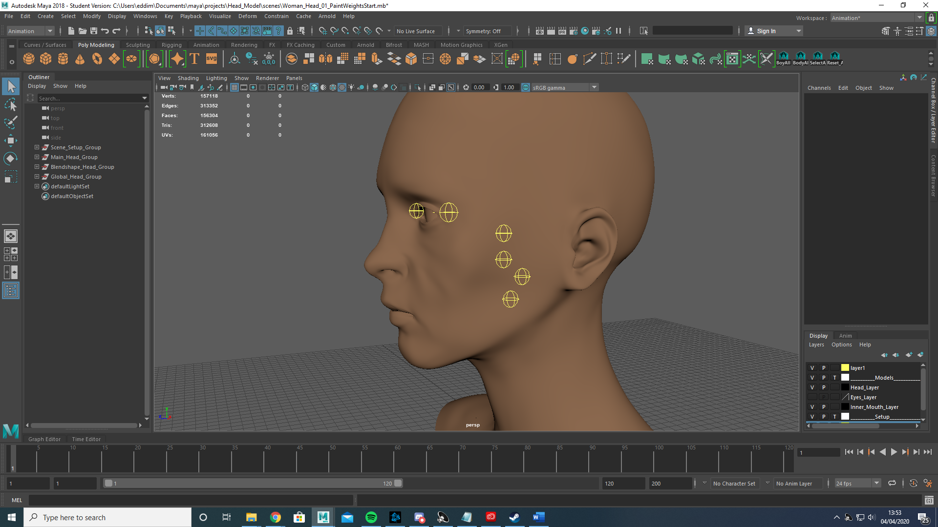

The L and R eye socket joint would deform the eye sockets respectively and be parented to the Top Head Joint which would allow minor deformation of the top of the head (although not often used can be helpful for cartoon characters) while the Jaw Joint would handle the deformation of the jaw and be parented to the Bottom head joint. The Head joint doesn’t not handle any deformation and is instead used to control the position and orientation of the head as a whole.

Once the joints had been placed, I moved on to the controllers, using NURBS circles I point constrained the circles to the joints before deleting the constraint and freezing the transformations and deleting the history. This ensured the controllers pivot point was in the exact position of the joint.

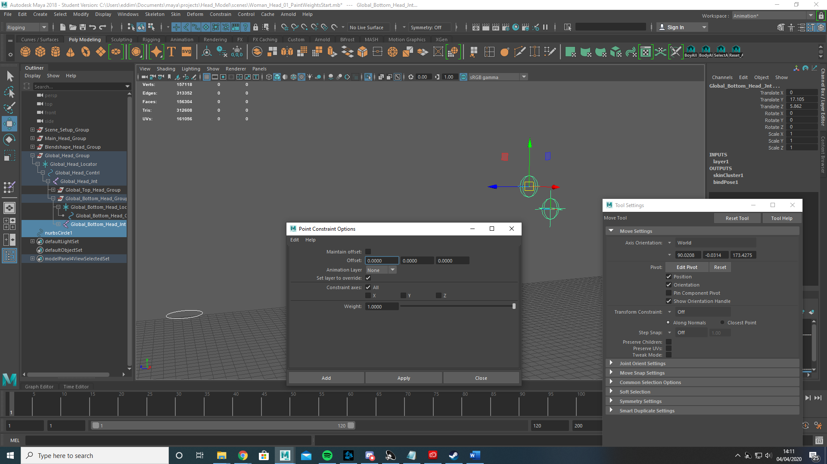

I then did the same with a locator and group to ensure that there were no unwanted translations that would affect the movement of the joint.

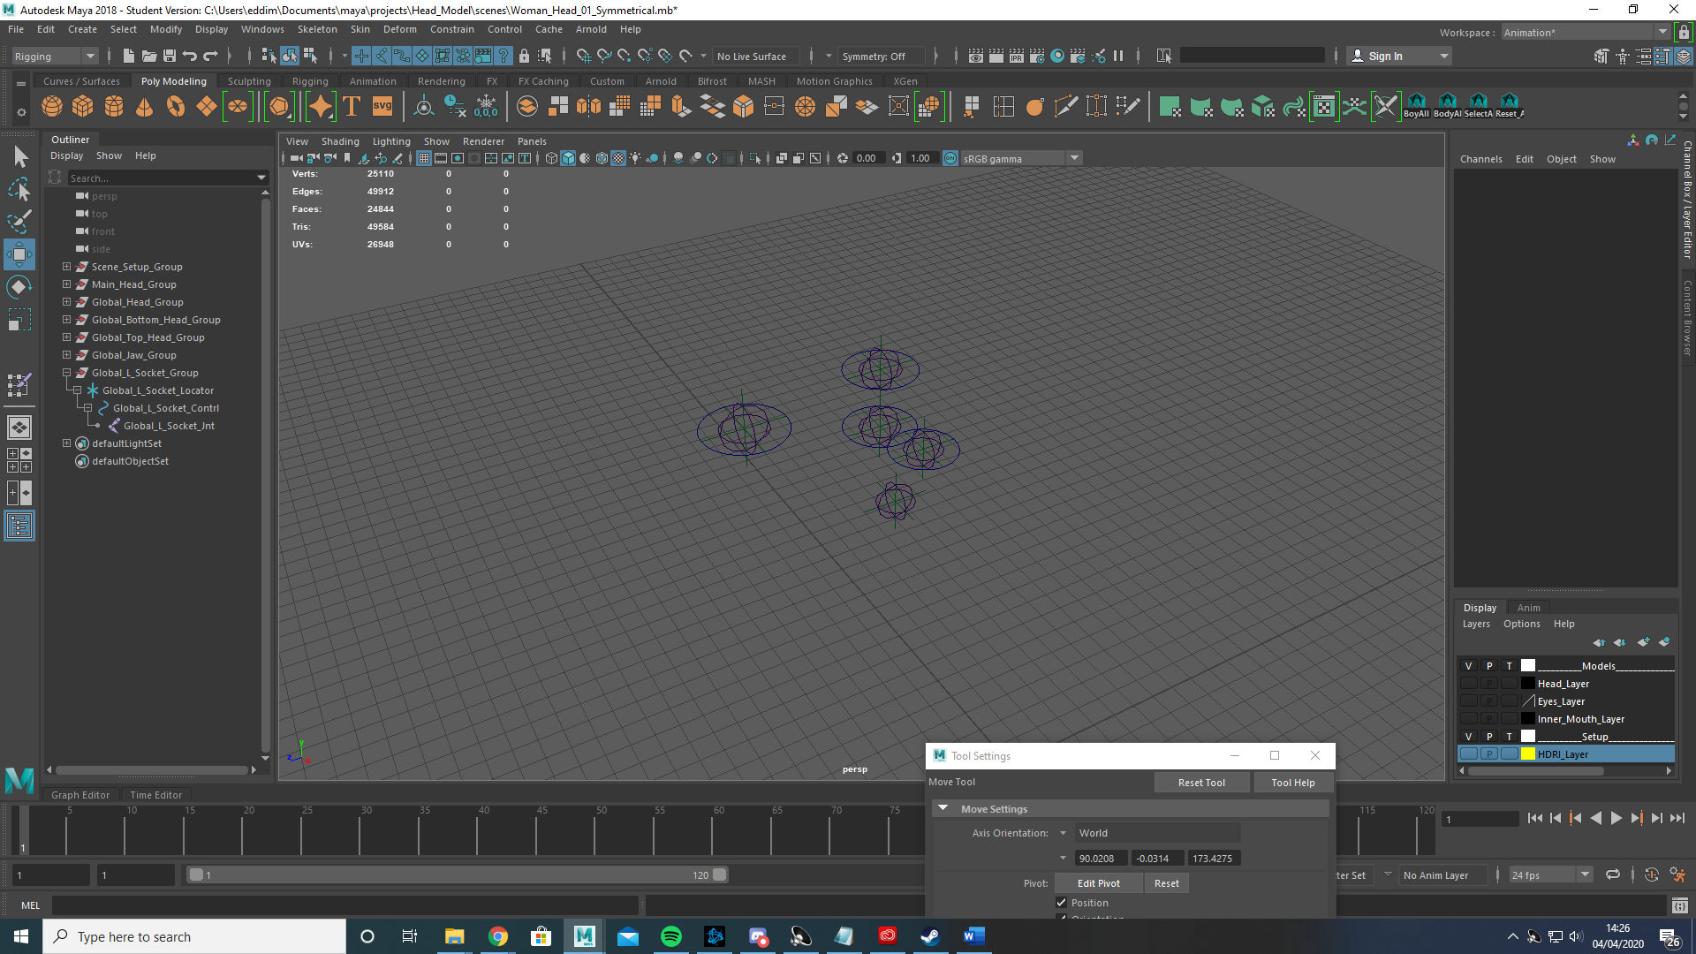

The grouping looks like this with the Joint parented to the controller, the controller to the locator and finally the locator to the group. This was done for each joint.

I then changed the shape of the NURBS circles to better represent what aspect of the mesh they were controlling. Using Control vertexs to ensure the controllers remained zeroed I manipulated the circles into the desired shapes.

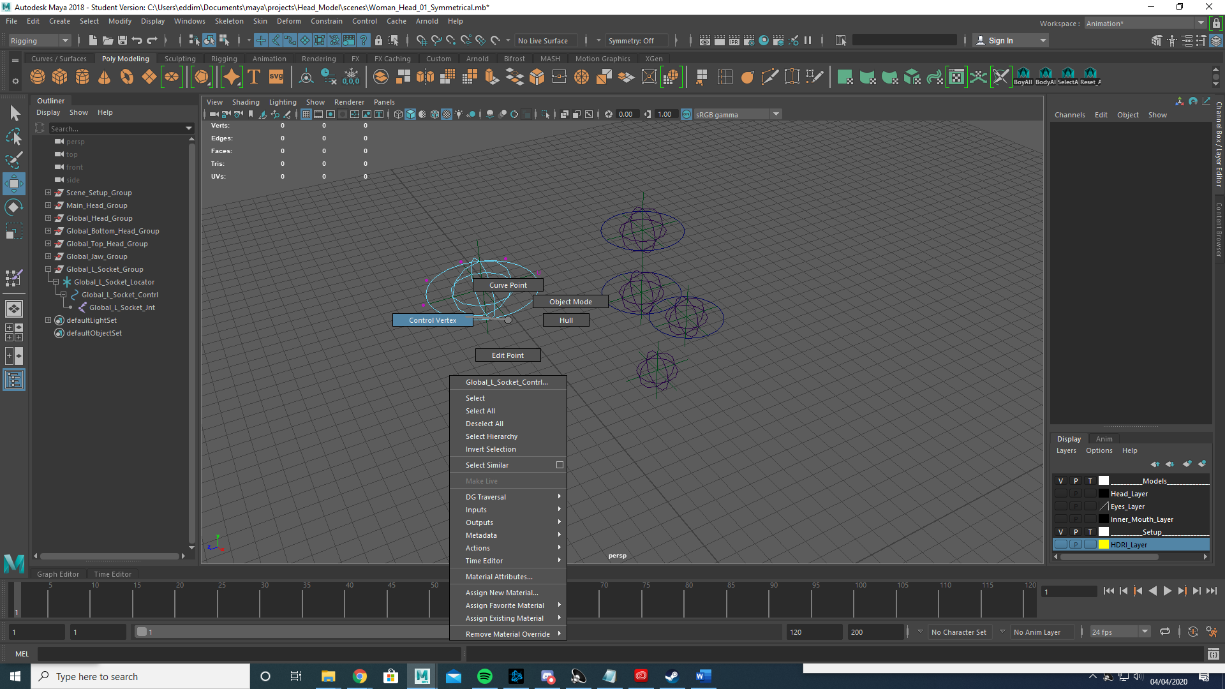

I then moved on to skinning the global Joints. By locking all but the Head Joint and flooding the head joint I could then paint each joint by taking influence from the Head Joint. 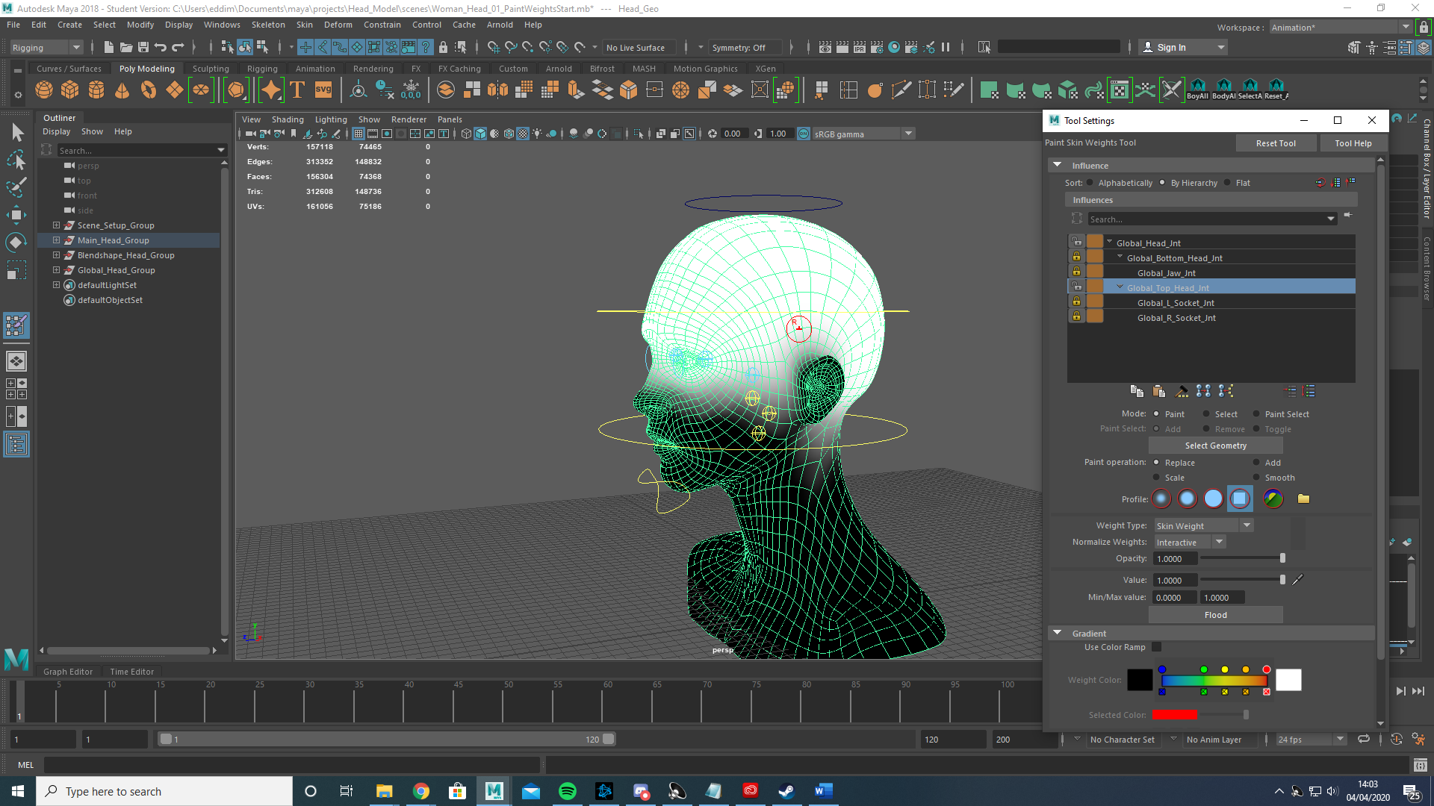

To do this I simply unlocked the Head Joint and the Joint I was currently working on. This ensured I did not accidentally steal influence from a previously completed joint.

This concluded the Global Joint set up and I moved on to the Local Joints.

Local Joints

The Local Joints controlled more specific areas of the head such as the ears, cheeks and nose. My process was very similar to how I did the global Joints with only a few differences.

First I duplicated the head mesh without any joints, then using this new mesh I placed a Local Head Joint, L and R Ear, Ear Tip, Nose, L and R Nostril, Nose Tip, Mouth, Chin and L and R Cheek Joints.

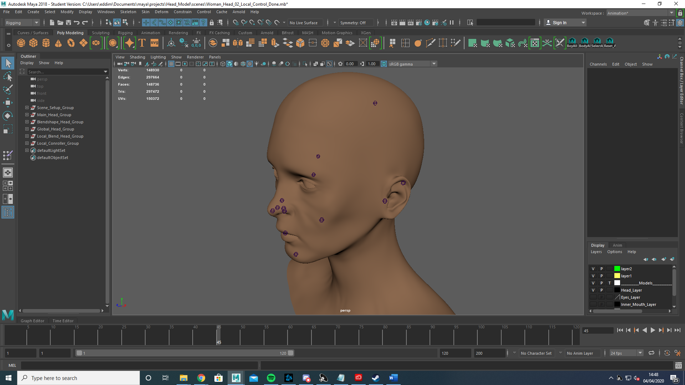

Then in a similar fashion to the global joints I created locator and group for each joint (but no controllers, those come later)

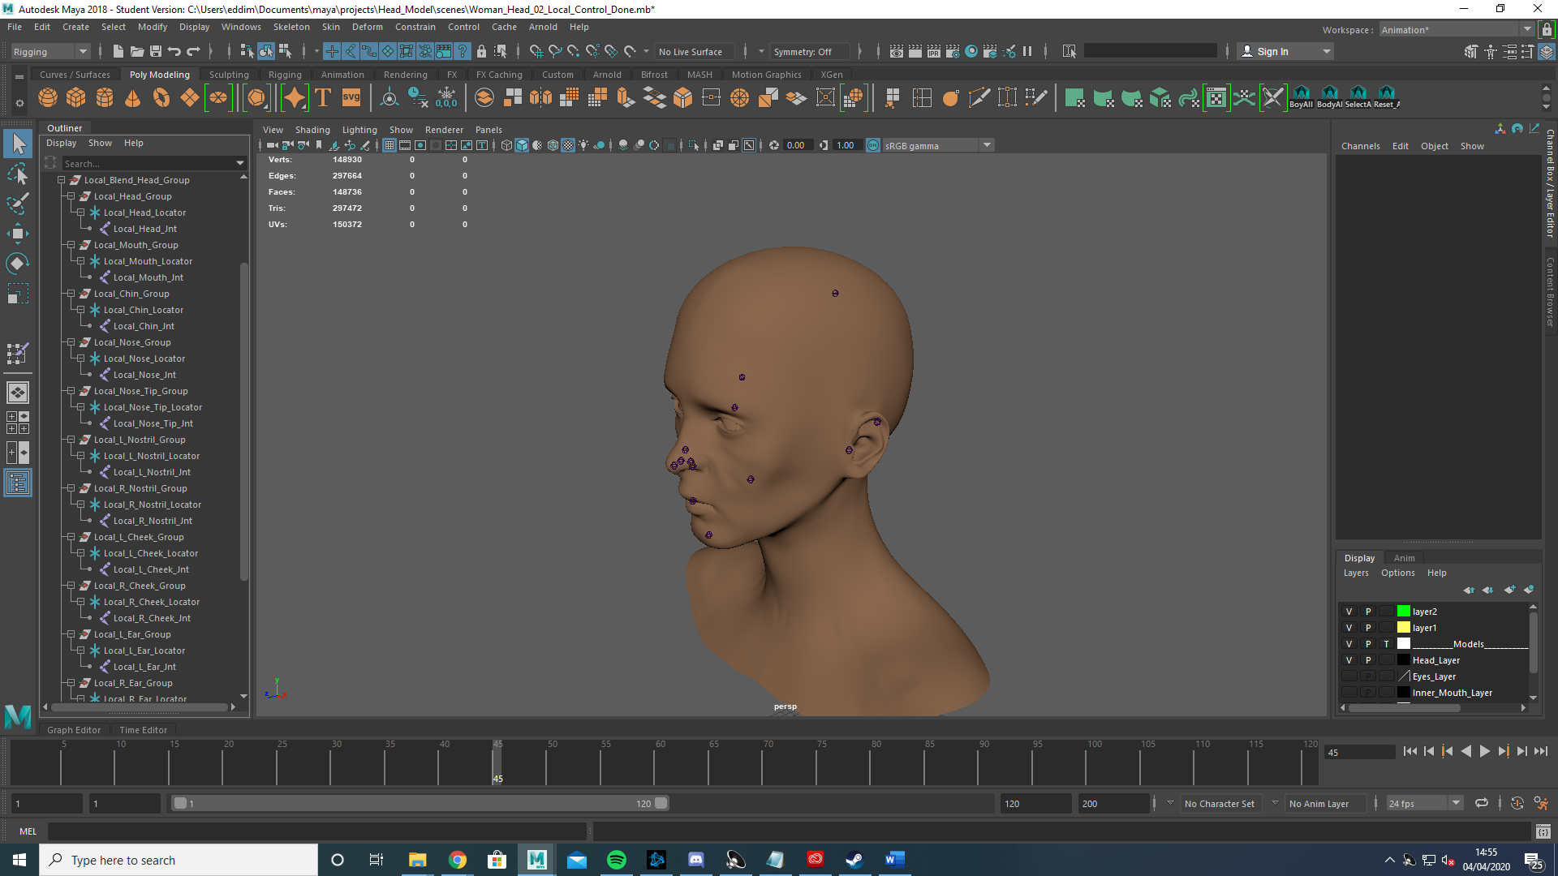

Duplicating the local joints I then moved the duplicated local joints back down to the original head mesh.

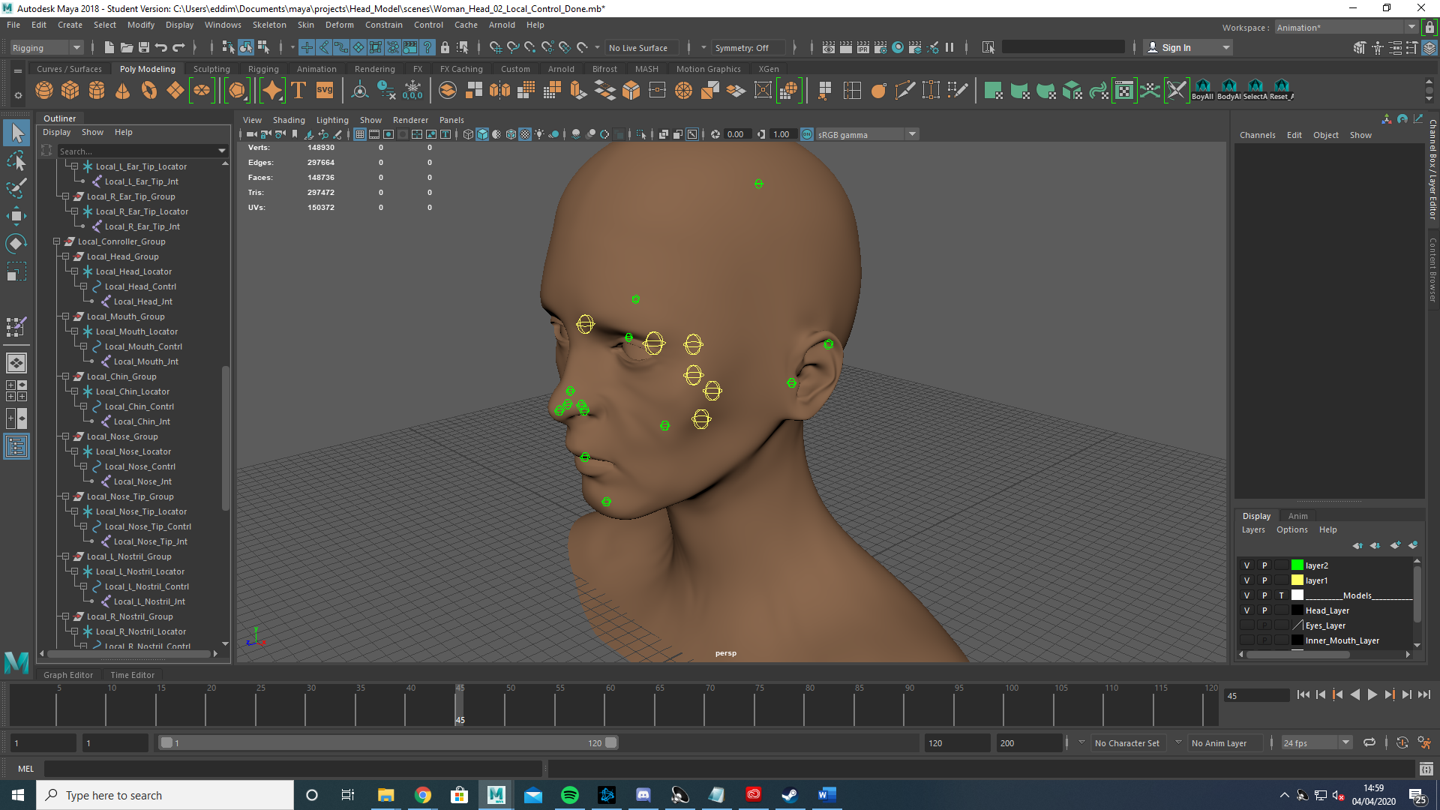

Then using the same process as the global controllers (Point constraint, freeze transformations and control vertex) I created appropriate shaped local controllers on the original head mesh only.

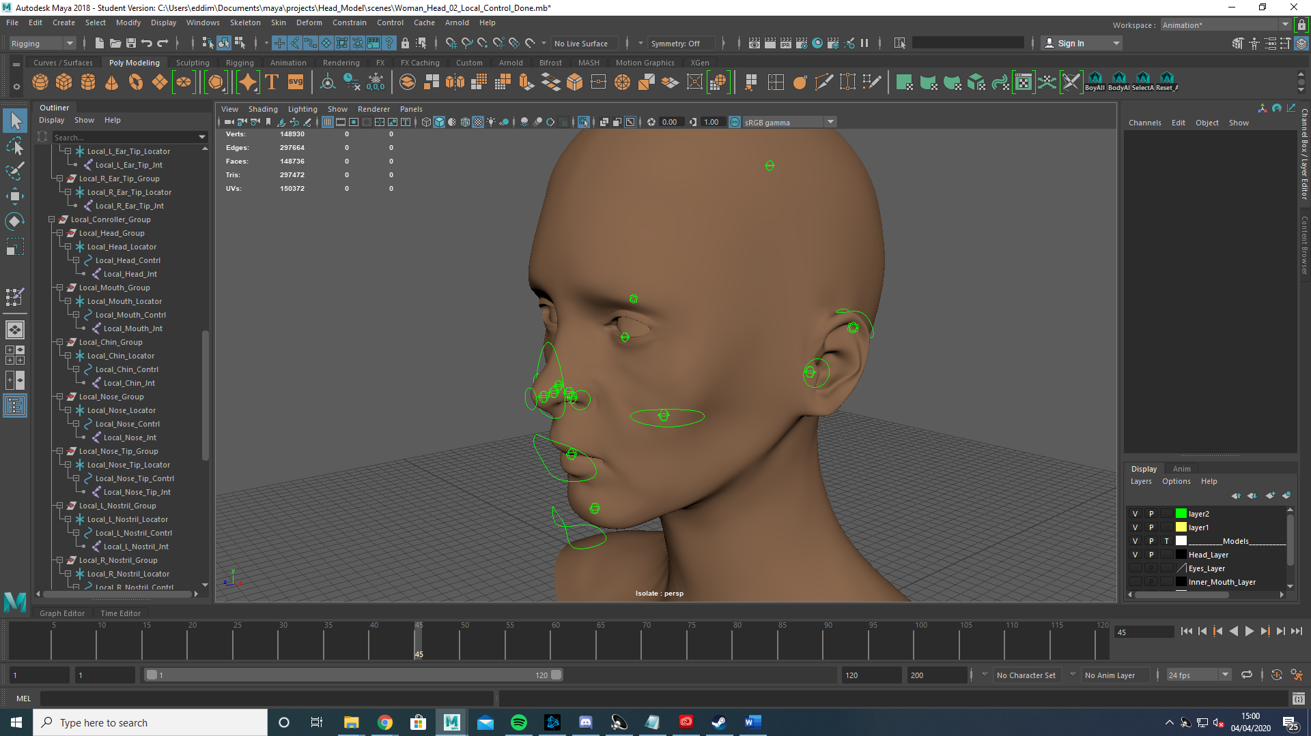

Then once again using the exact same method of flooding the head joint and working on one joint at a time like with the global joints I skinned the local head mesh before mirroring the skin weights.

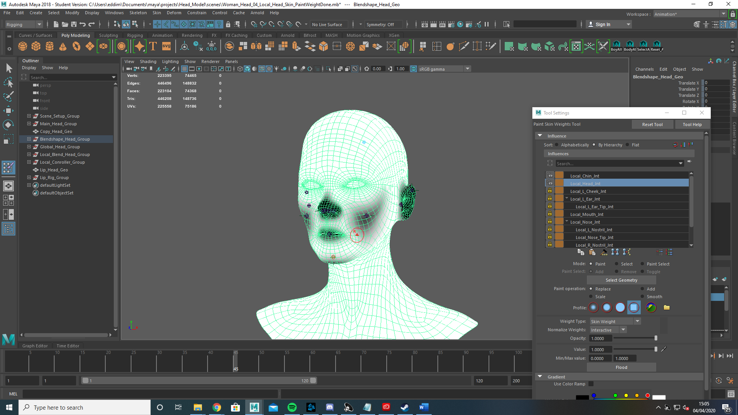

With the skinning completed I created a blendshape between the local head and the global head. This would mean that any deformations on the local head would be replicated on the global head by the blendshape.

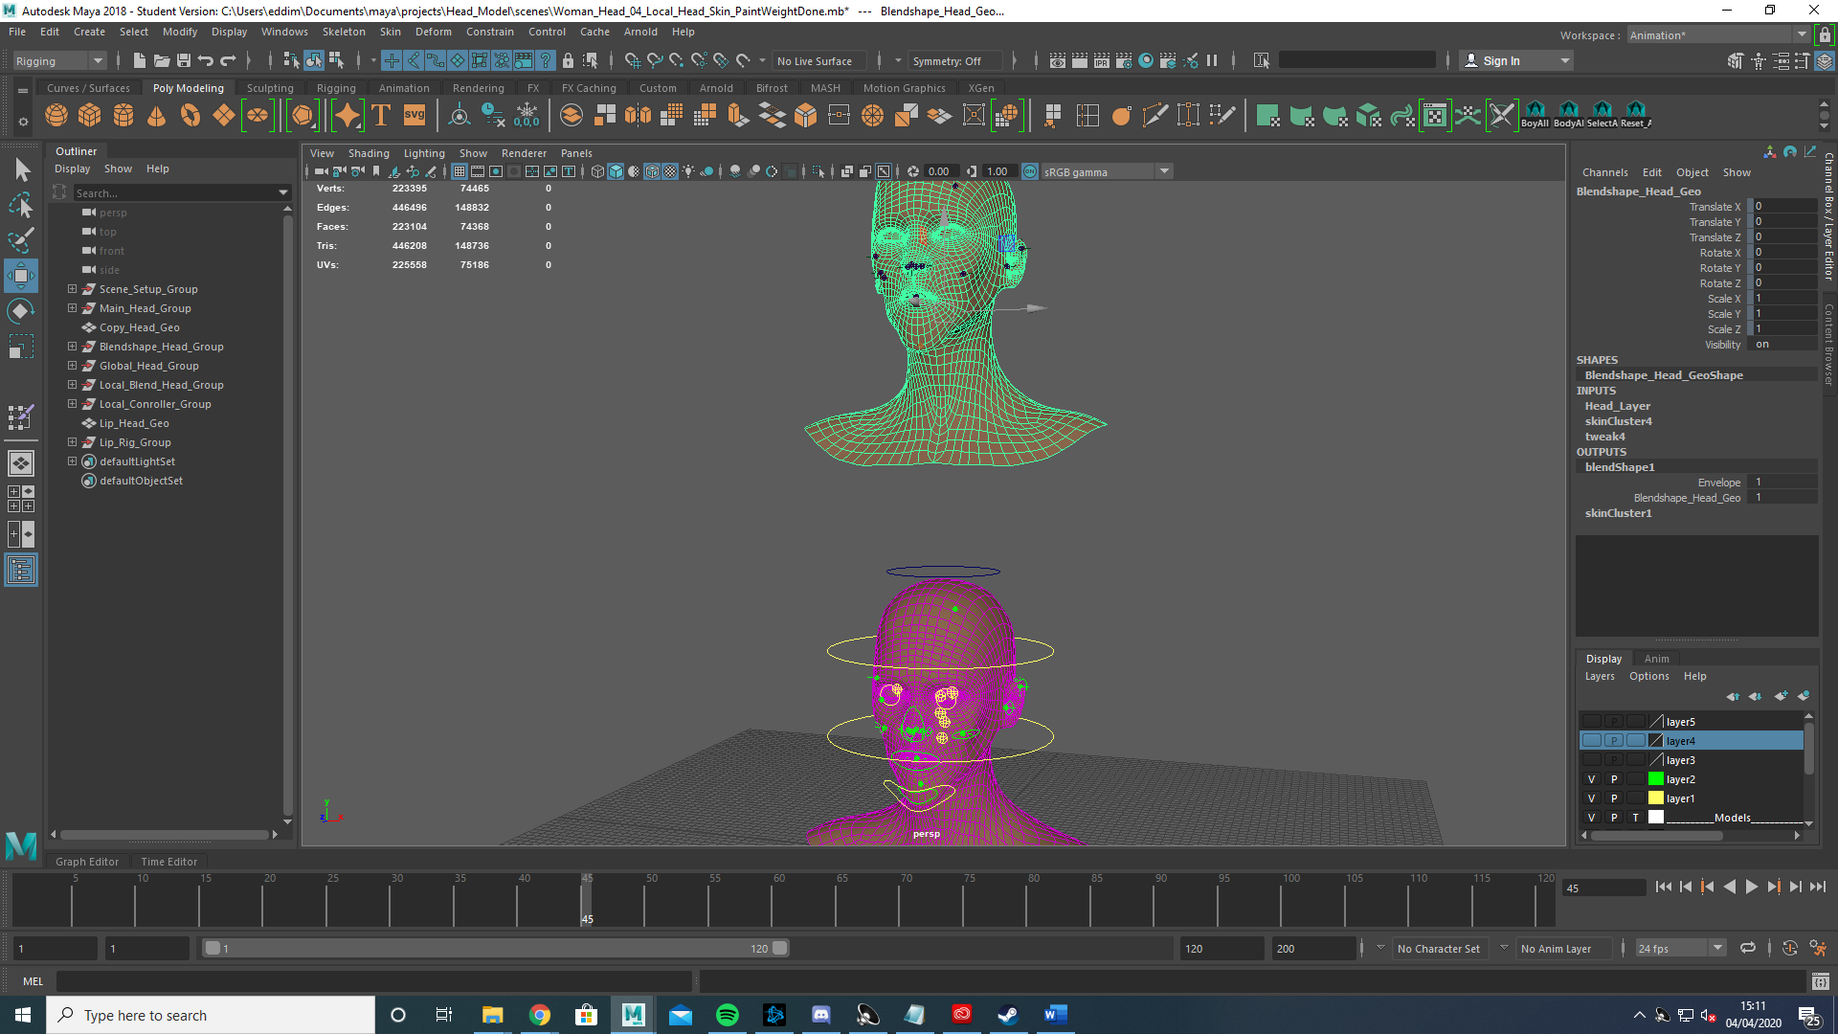

After ensuring the blendshape was functioning correctly I used the connection editor to connect the Global Head Local Controlers to the appropriate Local Joint Locators on the local head.

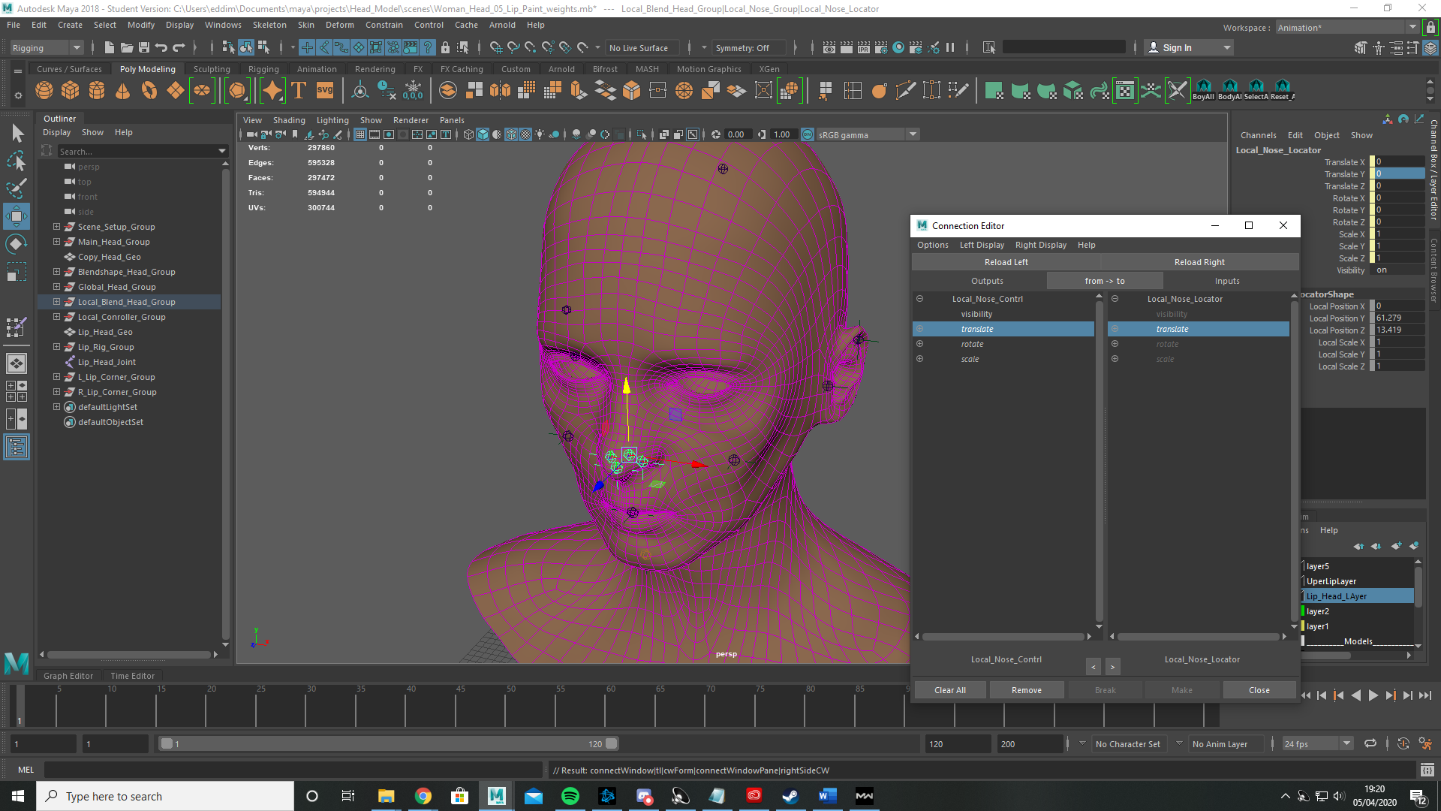

This would ensure that when I moved the controller it would deform the local head before the local head blendshape would deform the Global Head in the appropriate manner.

Lip Joints

Again I duplicated the head mesh and created two NURBS planes segmented into 8 parts and positioned them appropriately in the mouth.

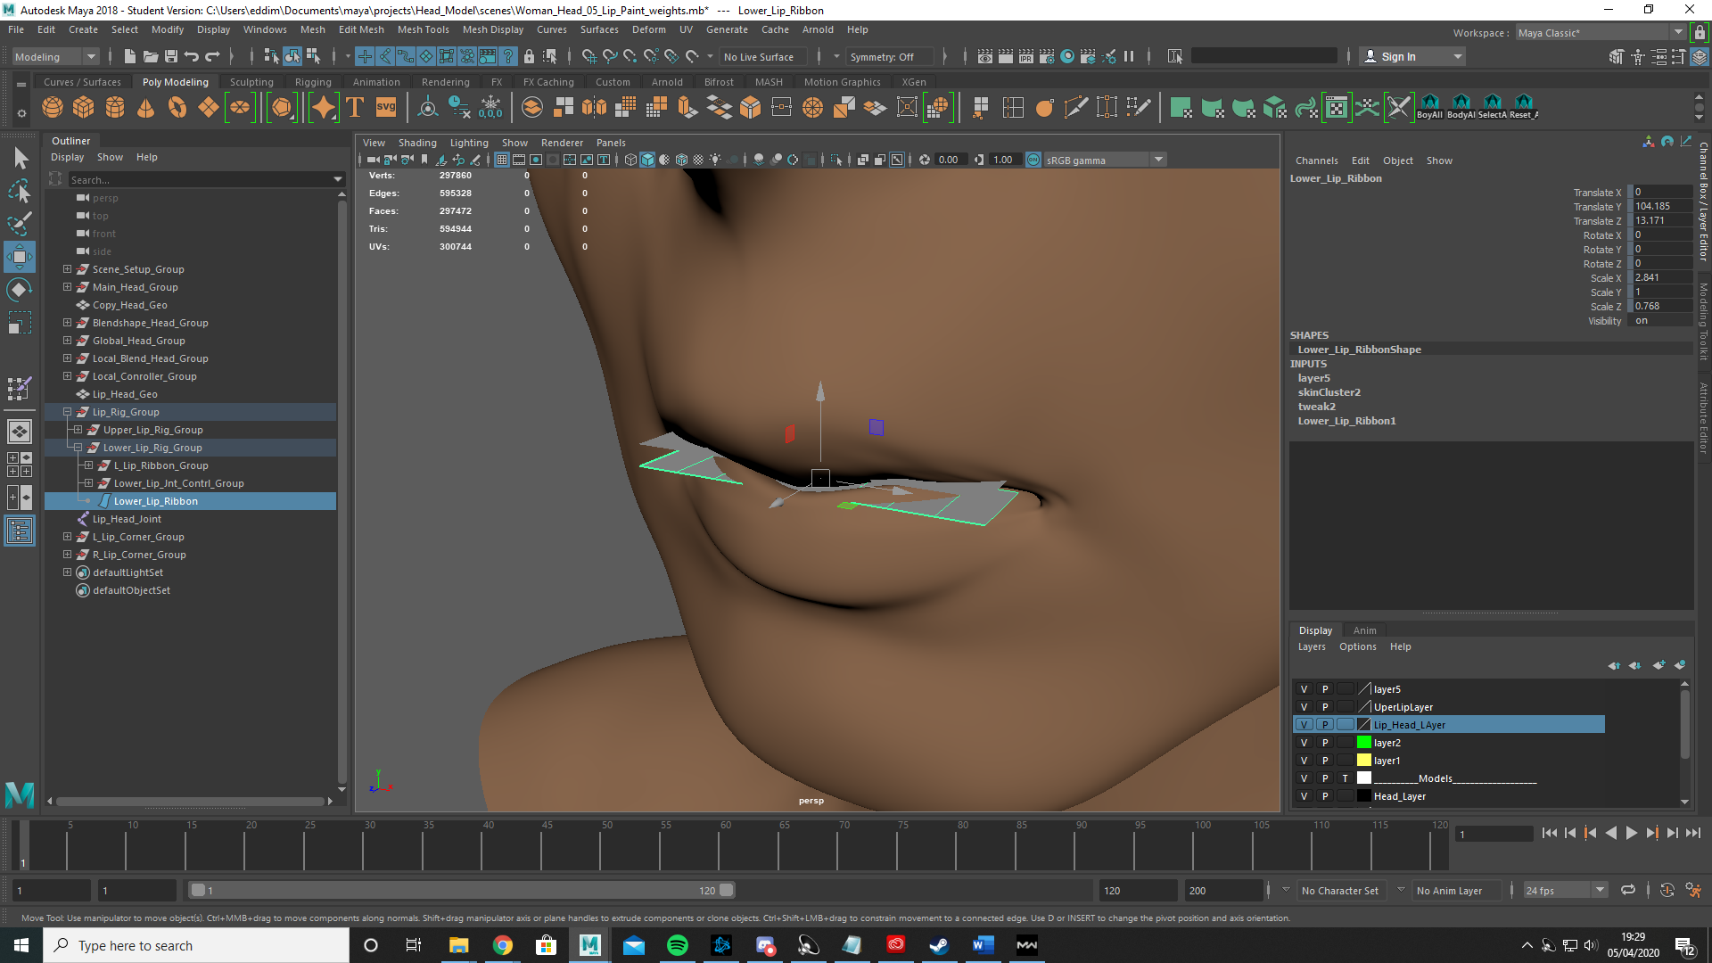

I then snapped five joints onto the center of the plane. These joints would be the ones I manipulate but would themselves not be skinned to the head.

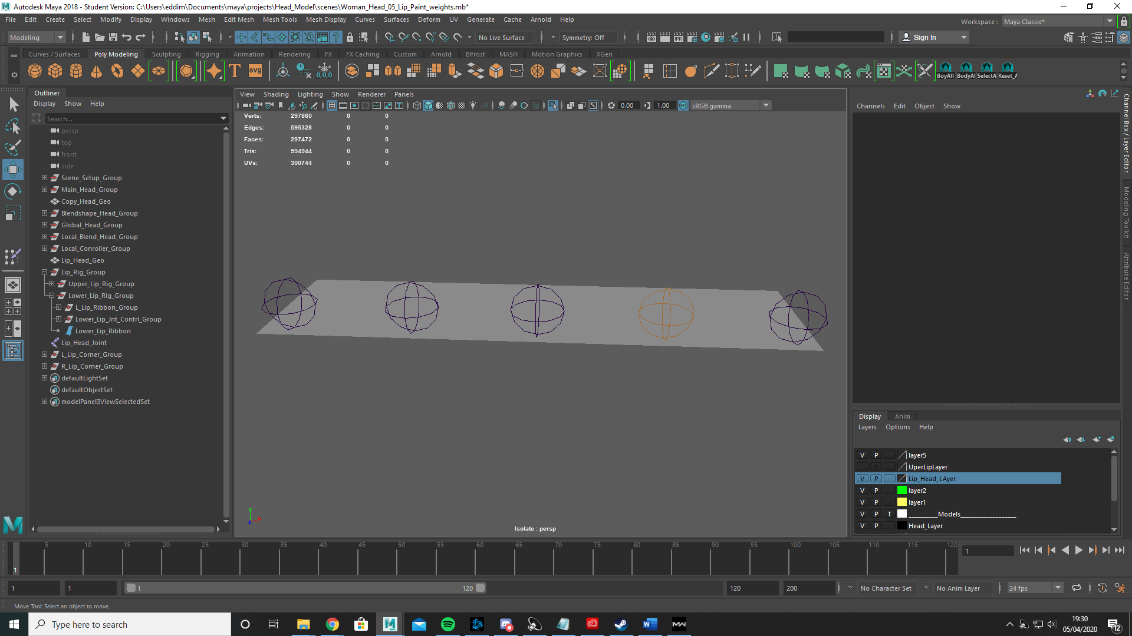

I then selected the five joints and created an nHair for each joint. I did this for the follicles that nHair creates which then allowed me to create 8 joints positioned on the lip ribbon. These 8 joints are the joints I will skin onto the mouth as it will allow me more precise control over mouth deformations.

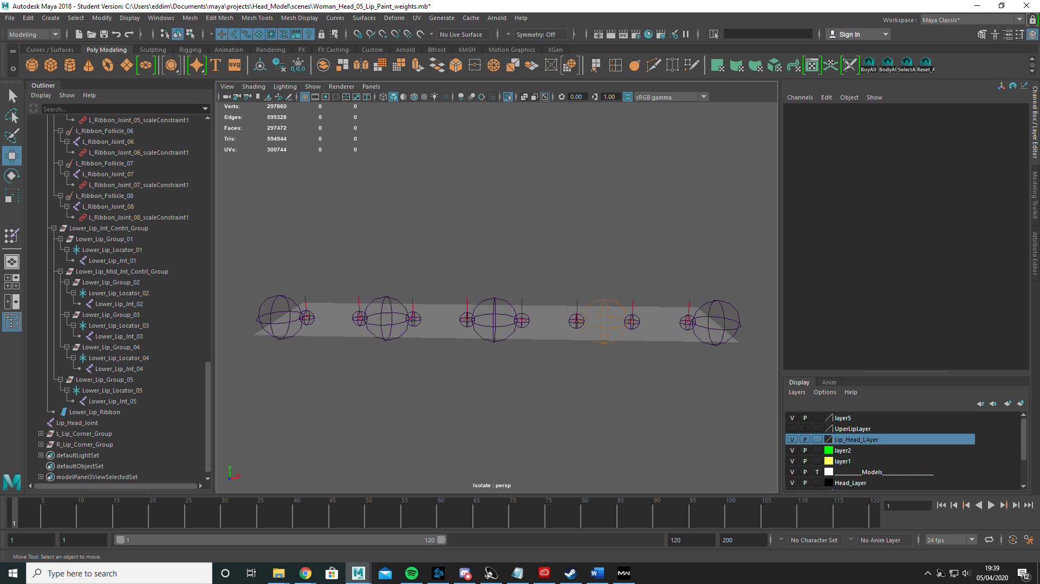

Once again I created locators and groups for the five joints I would manipulate to cause deformations. Finally I scale constrained each joint locator to the smaller joints.

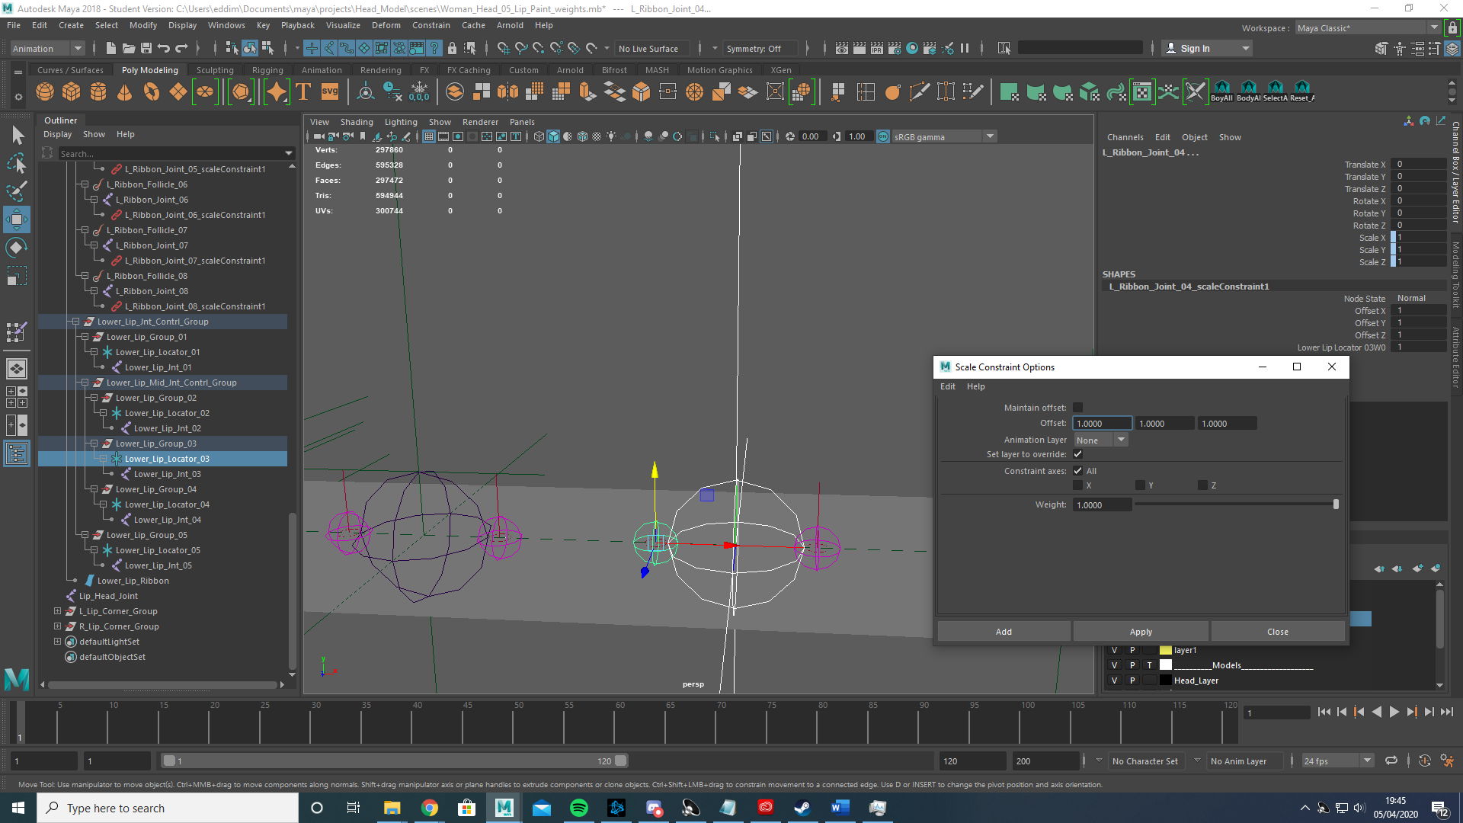

This would ensure that if I wanted to manipulate the scale of the control joint the smaller follicle joint would change scale appropriately and the desired deformation would occur.

I then skinned the 5 larger joints to the NURBS plane.

With that done I created 6 joints for the corner of the mouth, 3 on each side. I once again created a locator and a group for each joint. 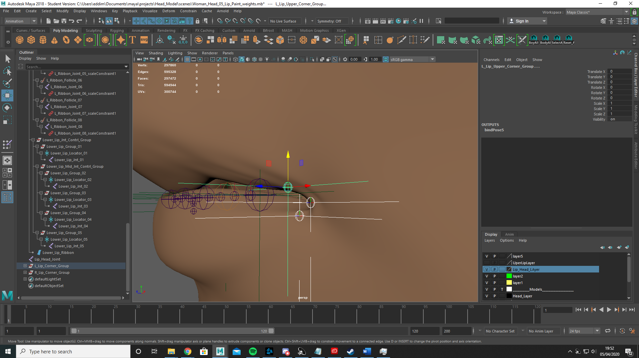

I then created a joint in the head to once again flood with paintweight as I did with the global and local joints before once again locking and unlocking two joints while painting.

To give myself more control over what I was painting and to ensure I didn’t accsidentaly paintweight the upper lip to a lower lip joint I painted by selecting verts.

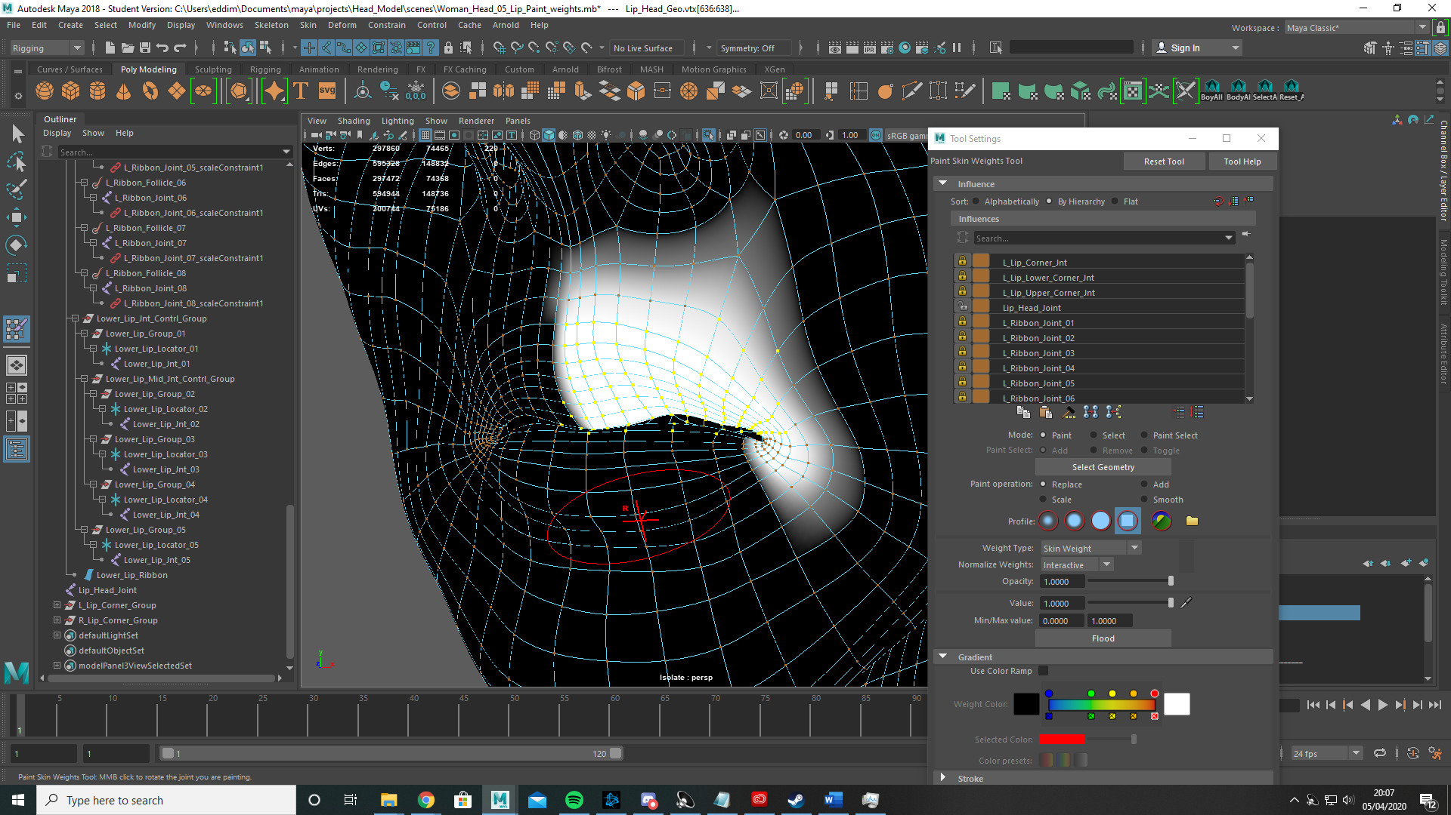

This ensured I only painted verts I wanted painting. I did this for the upper lip, lower lip and both corners.

With the lip paint weights done I duplicated the 10 upper and lower lip control joints and the 6 corner joints and placed them onto the global head.

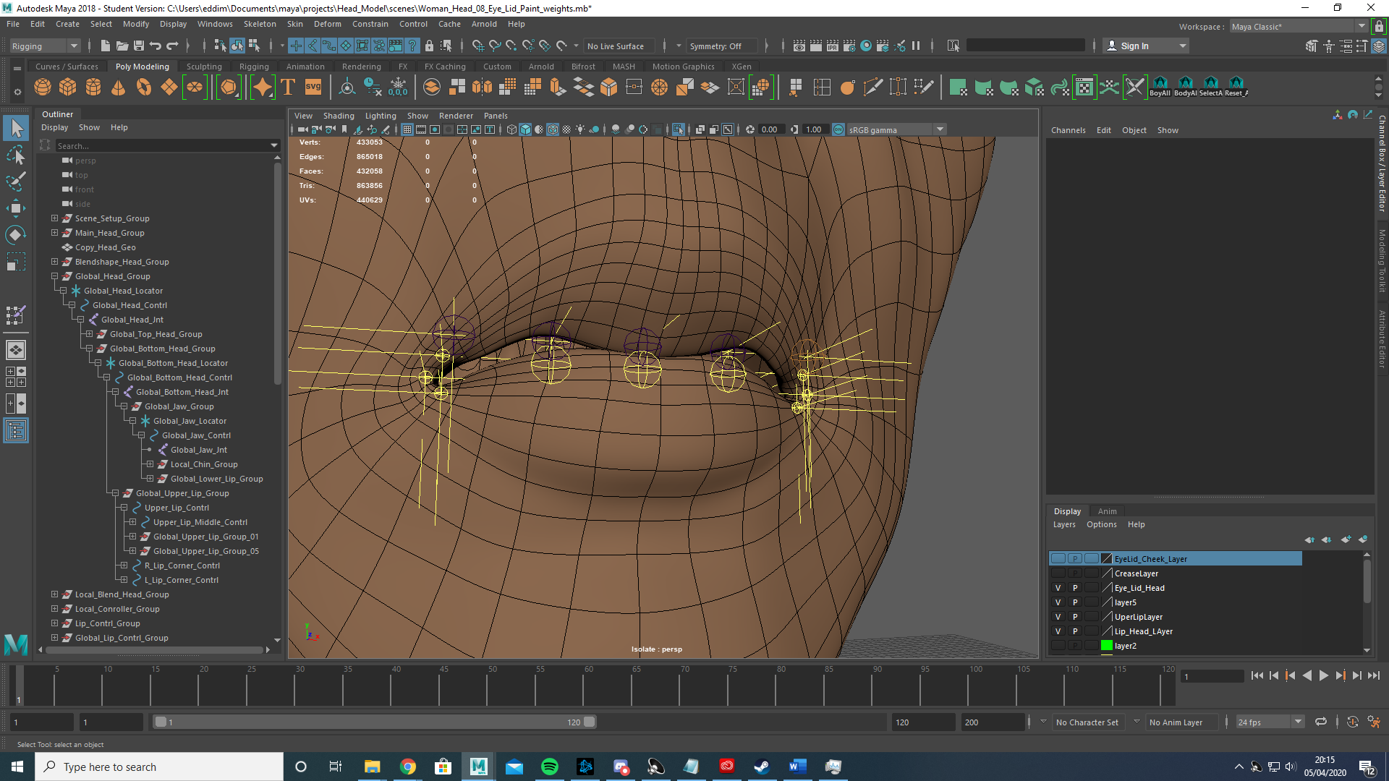

I then set about creating controllers for these joints using the same process as I did for the Global and local joints by creating NURBS curves, locators and groups for the joints. Then once again i created a blendshape between the lip head and the global head and using the connection editor I linked the controllers to the correct joint locators.

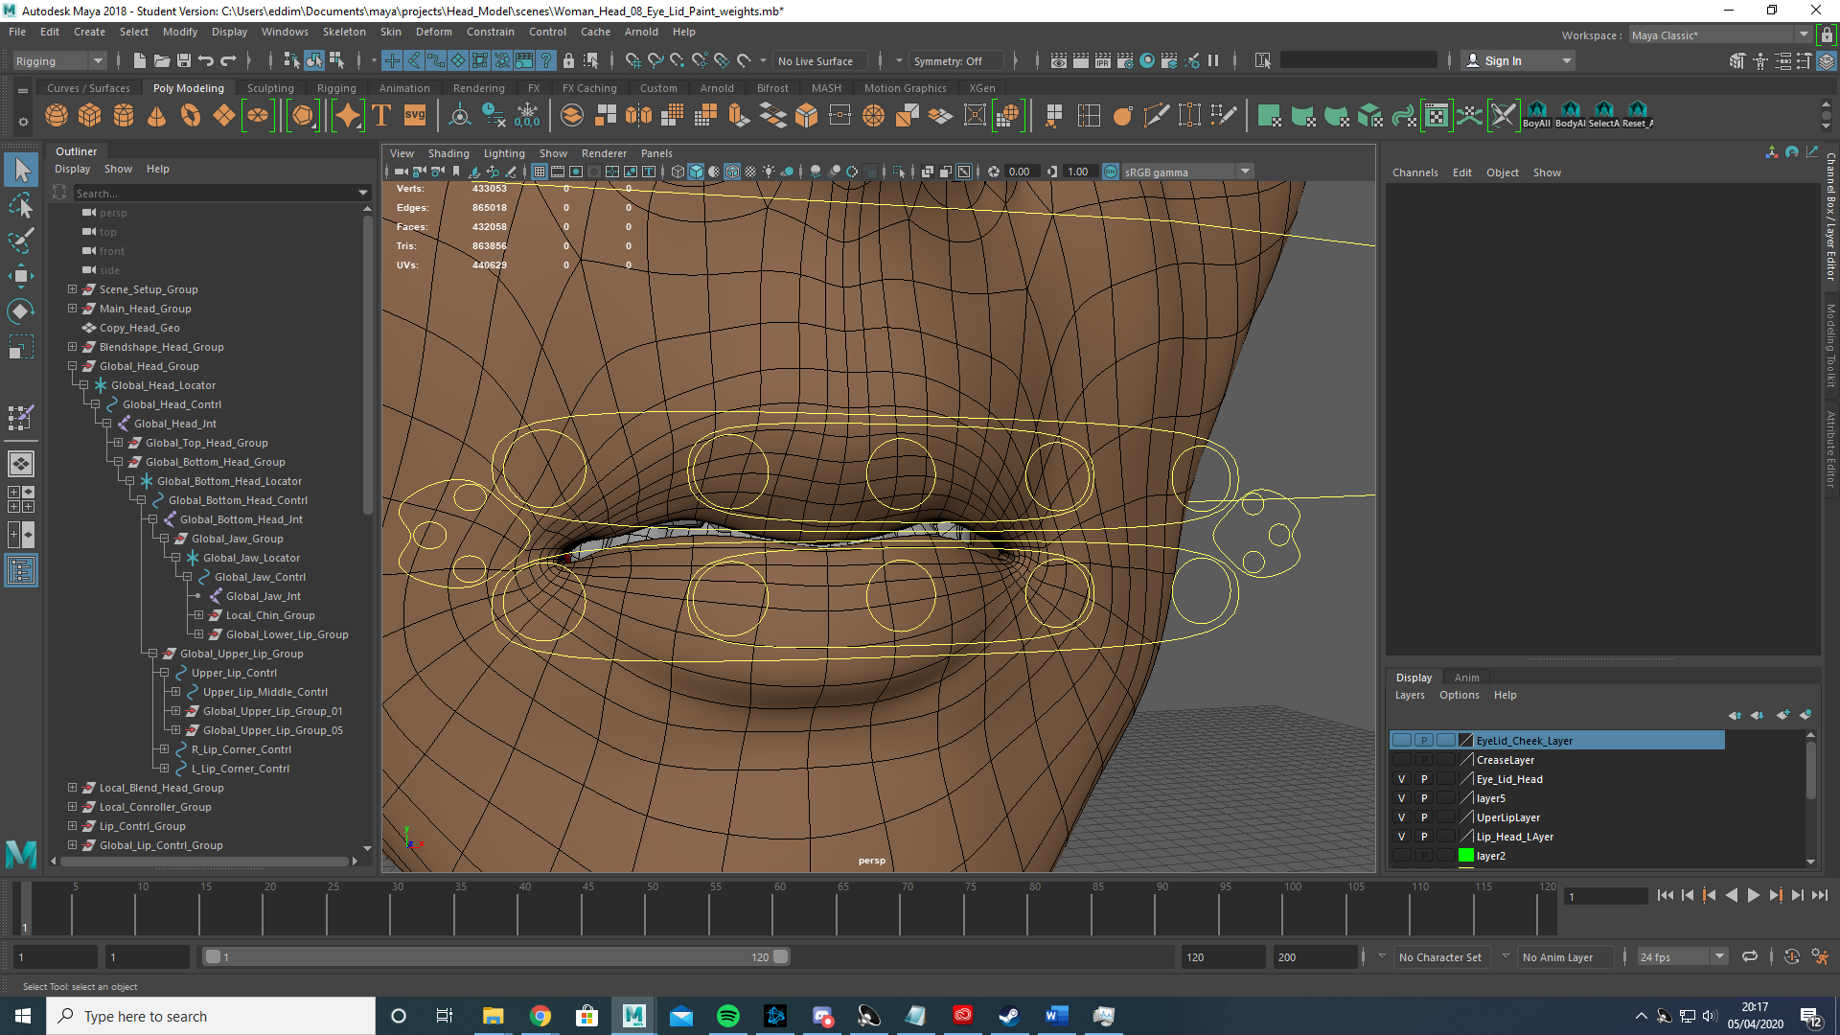

Eye joints.

After once again duplicating the head mesh I created I head joint to take skinweight from and then duplicated the left and right eye socket and moved them into the correct position on the duplicated eyelid Mesh. Using these duplicated joints are positional indicators I snapped 8 joints directly to the duplicated left socket joints and deleted the duplicated left eye socket, this would ensure the eye lid would pivot correctly. From there I then placed 8 joints on the left eyelid each parented to one of the positioned socket joints.

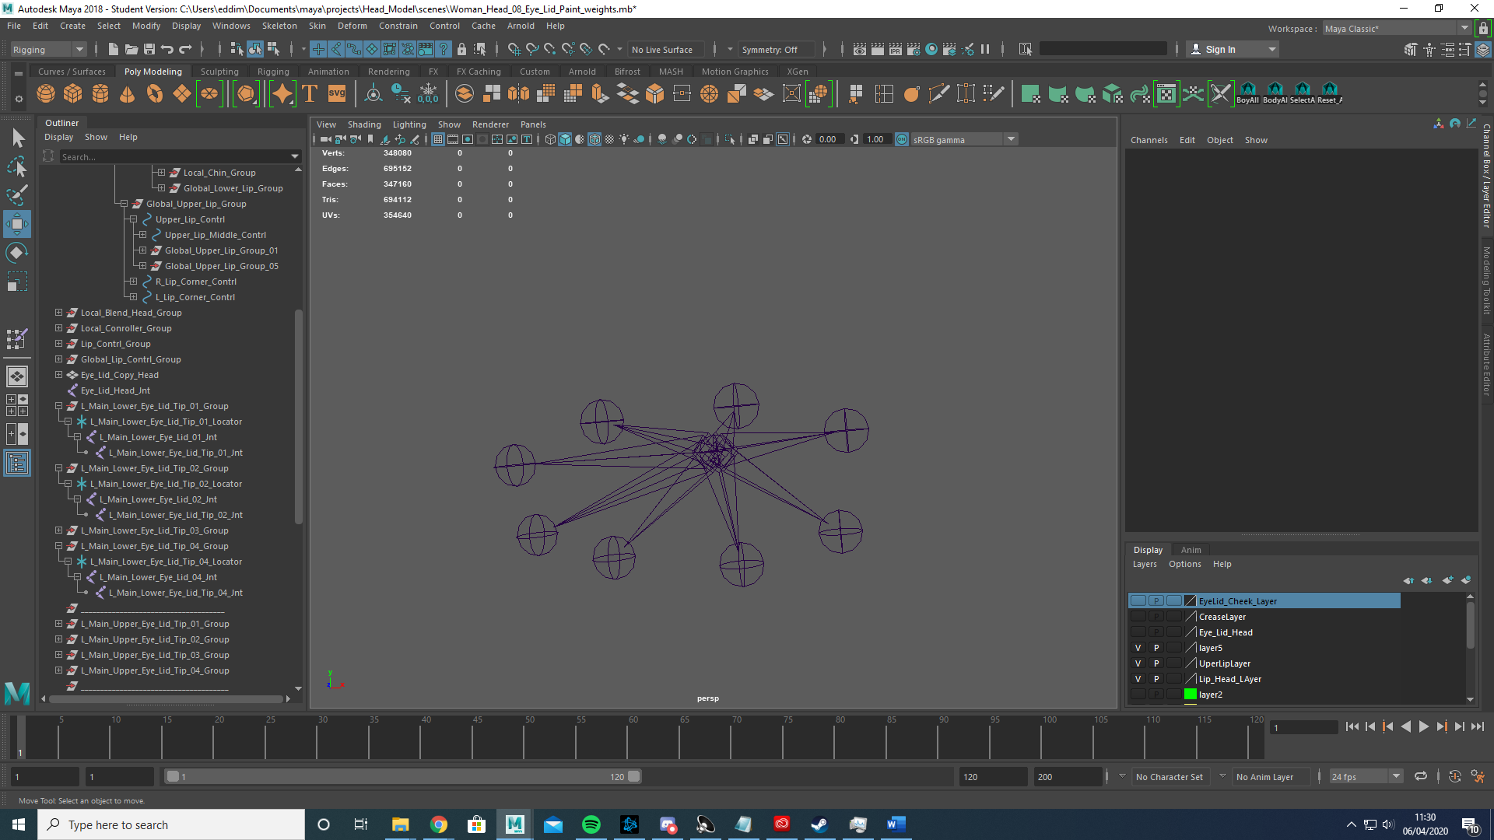

I then parented the 8 socket joint to the head joint and mirrored the joints to produce the right eyelid joints before unparenting them.

With that completed I once again created a locator and group for each eyelid joint before I moved on to create 8 crease joints that would control the deformation just under the eye lids using the same process as I used with the eye lid.

I did the same with 2 cheek joints.

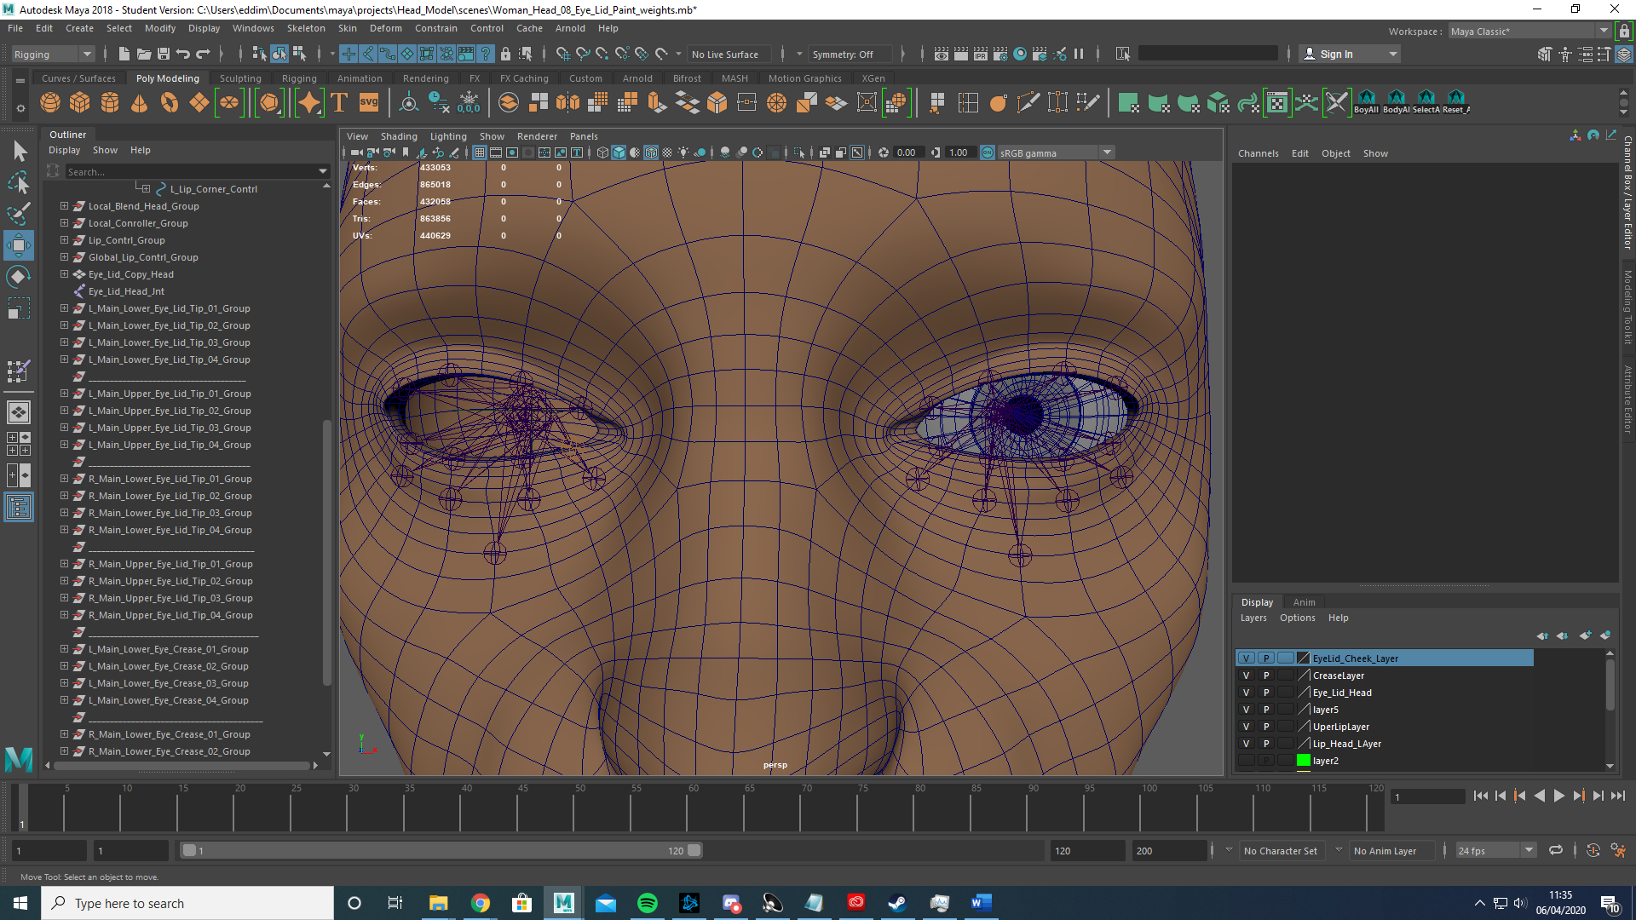

Once again I skinned the eyelids using the same technique of before of taking influence from the head joint and painting only one joint at a time.

With the skinning complete I once again created controller’s using NURBS Curves on the global head.

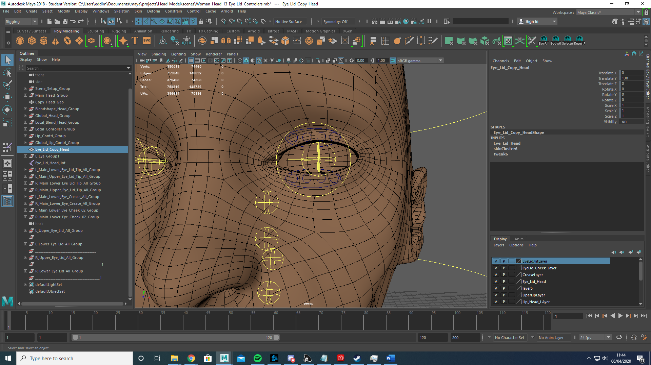

With that done I used the attribute menu to create a 0-10 sliding scale to control the eye crease joints and cheek joints before once again creating a blendshape link between the eyelid head and the global head and using the connection editor to connect the controller’s to the appropriate joints.

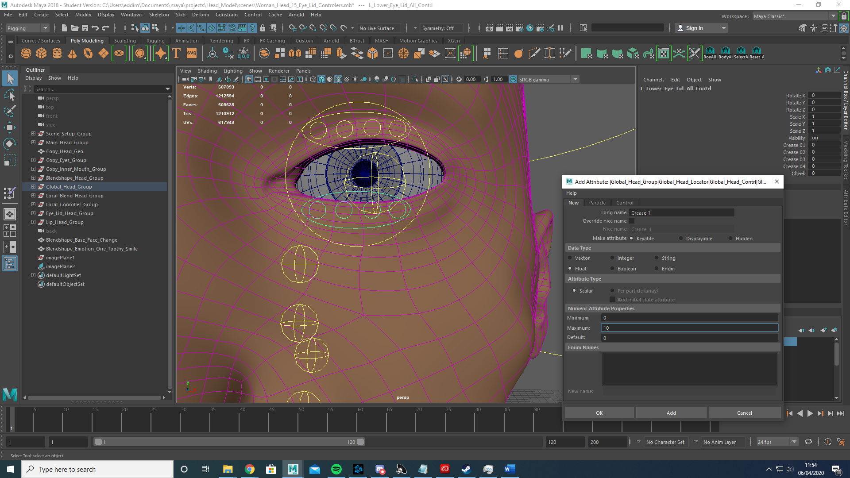

Inner mouth meshes.

Using the global head joint and jaw joint I skinned the mouth before parenting the inner mouth to the jaw controller.

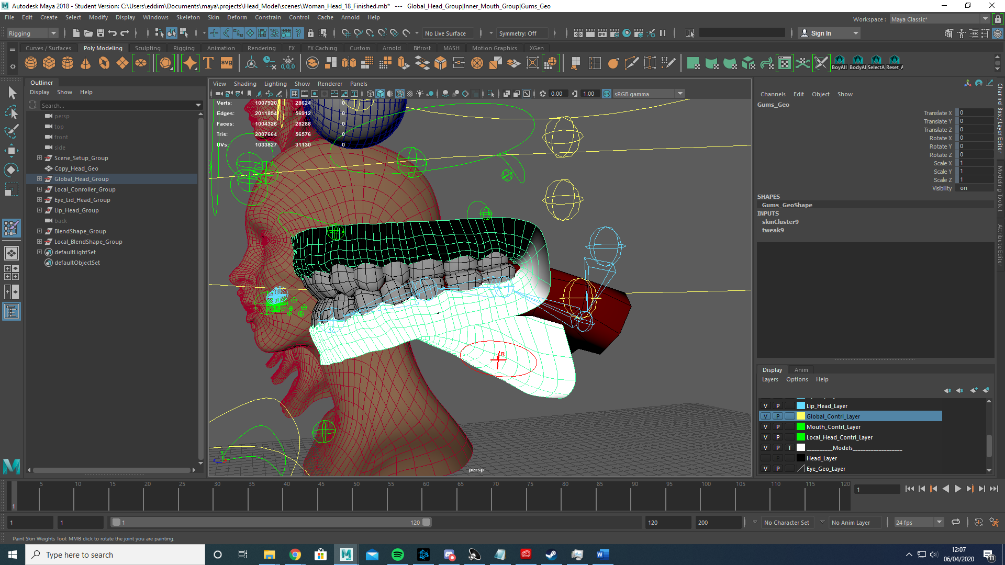

Then I simply parented the lower teeth to the jaw controller.

For the tongue I simply created 4 joints parented to the jaw joint and skinned them appropriately.

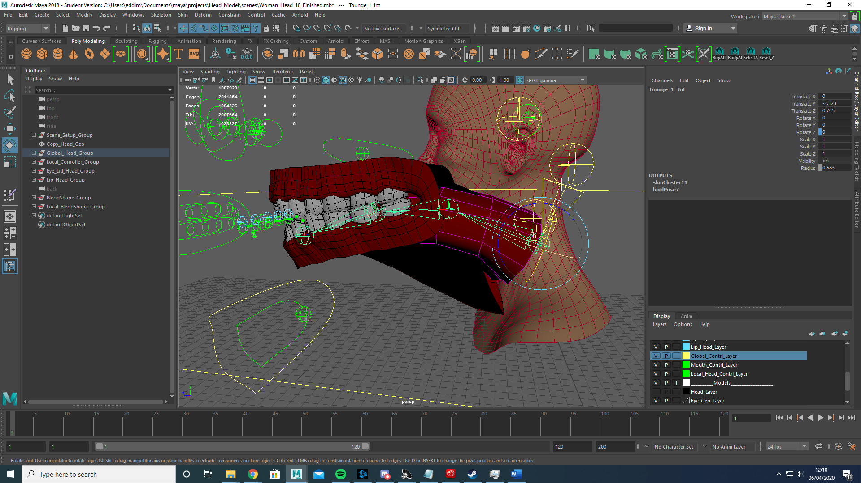

Then using the the attribute editor I added a -10 to 10 sliding scale to control each of the tongue joints to the mouth controller. With that the rigging section of this assignment is complete.

I then moved on to creating blendshapes for emotions.

However first using the lattice function I made changes to the base mesh. I decided that the character provided was very thin and had little fat around the cheeks. Using the lattice function I created a blendshape of the changes I made to the chin and cheeks before deleting the history to get rid of the lattice and linking the corrective blendshape to the global head.

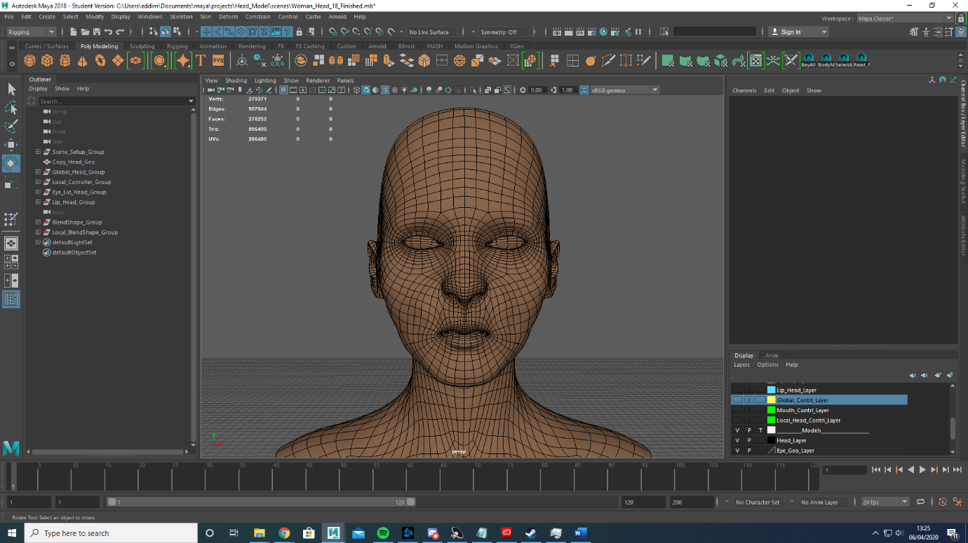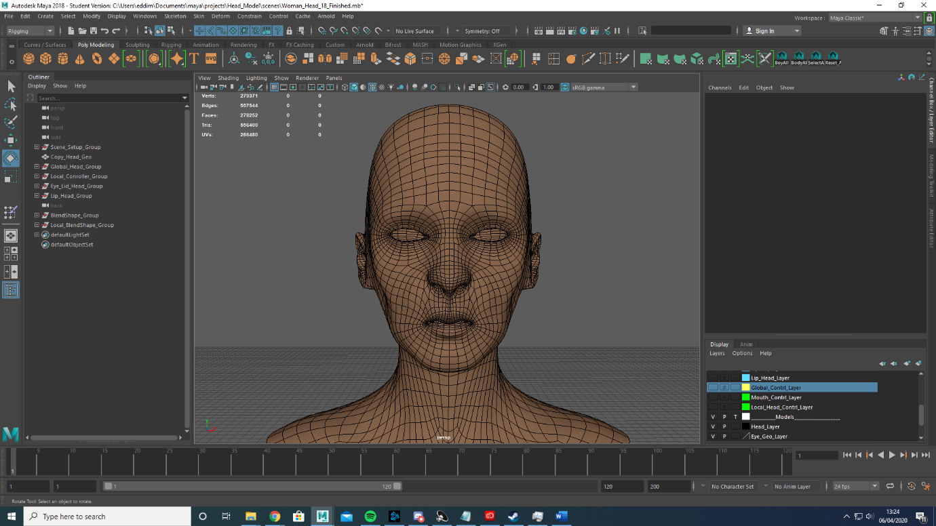

Corrective Mesh

Original Mesh

I then created 7 blendshape of common emotions using a combination of soft select and the sculpting tools maya provides. Unfortunately I made a mistake of duplicating the corrective blendshape which means the corrective blendshape must be turned off when using the emotion blendshapes.

The emotions I created were: Toothy Smile, Frown, Dubious, Toothy Anger, Curious, Snarl and Smirk.

UI

I then moved on to creating a UI interface for controlling the joints. First I added a UI locator to the local joints. This is to ensure that both the mesh controllers and UI controllers work independently of eachother as well as ensuring there are no unwanted translations.

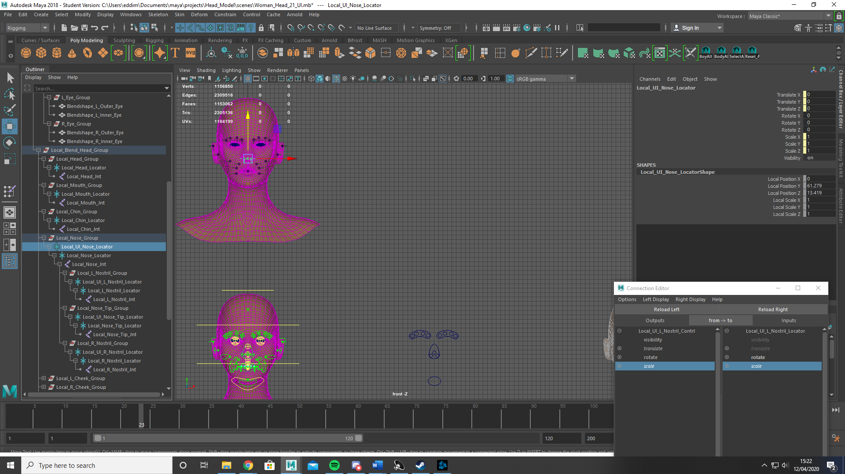

Creating appropriate looking controllers with NURBS Circles I then used the connection editor to connect translate and scale to the appropriate UI Locator, I then locked and hid the UI controllers rotate attribute as they are not required in the 2D UI environment.

Creating the mouth UI controller was slightly different to the majority of the UI controllers, this was due to the need for the UI controller to manipulate the rotation of the mouth when moved in the y direction. For example when the UI controller is moved in the negative Y direction the jaw joint should rotate positively in the x rotation. To achieve this I once again used the connection editor as well as the hypershade editor. First in hypershade I created a multiplyDevide node.

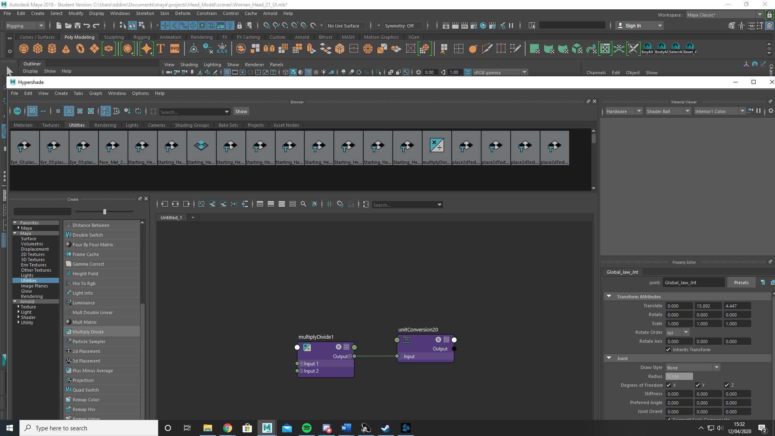

Then using the connection editor, I connected the UI Controller Y translate to the multiplydevide input 1. I then set the value of input 2 to -5, this would multiply the value of the y translate by -5.

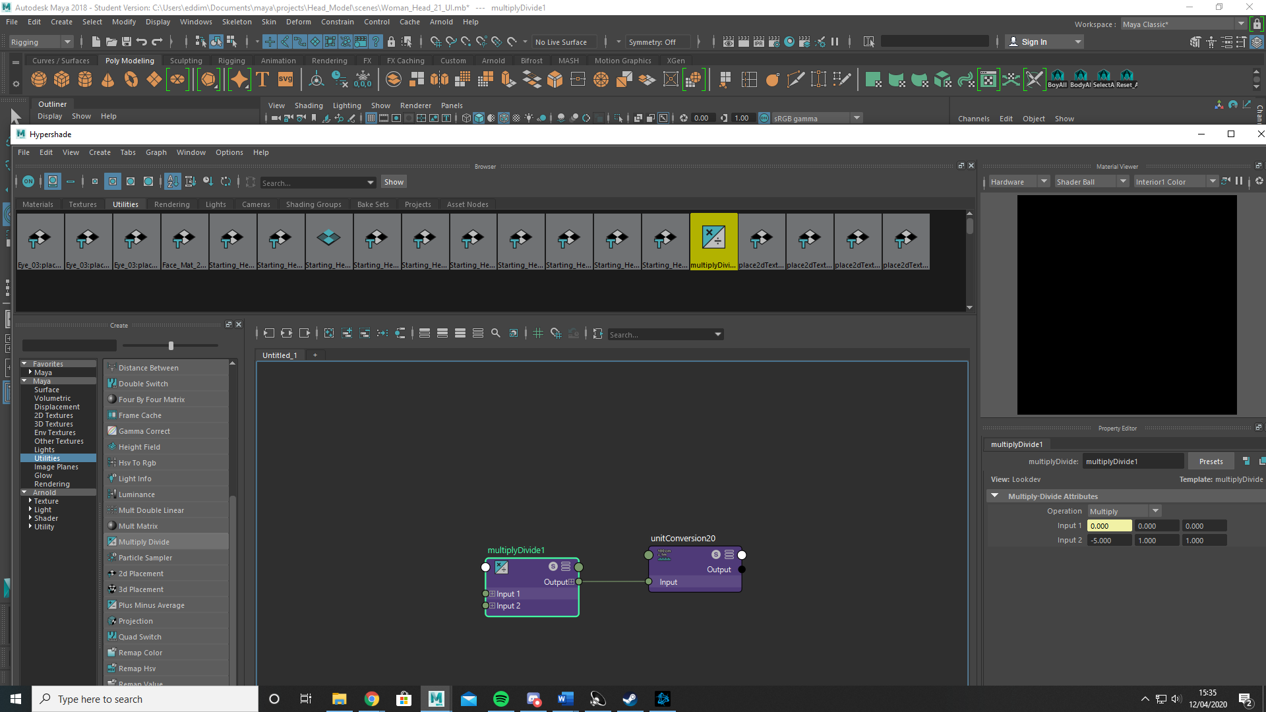

Then once again using the connection editor I connected the output from the multiplydevide node to the X rotation of the Jaw UI Locator. What this does is take the y translate value of the UI controller, multiply it by -5 then out put this new value to the UI Jaw Locator X Rotation attribute. So if the UI controller is moved down to -5 the UI Jaw Locators X rotation and the jaw joint by association is moved to -15 (Note: I later chance the x Input 2 value from 5 to 10).

I used the above technique to create the Ear UI and Eye Lid UI controllers however changed the x Input 2 value to 30.

I also set translations limits to ensure the UI controllers didn’t stray to far. I did this through the attribute menu.

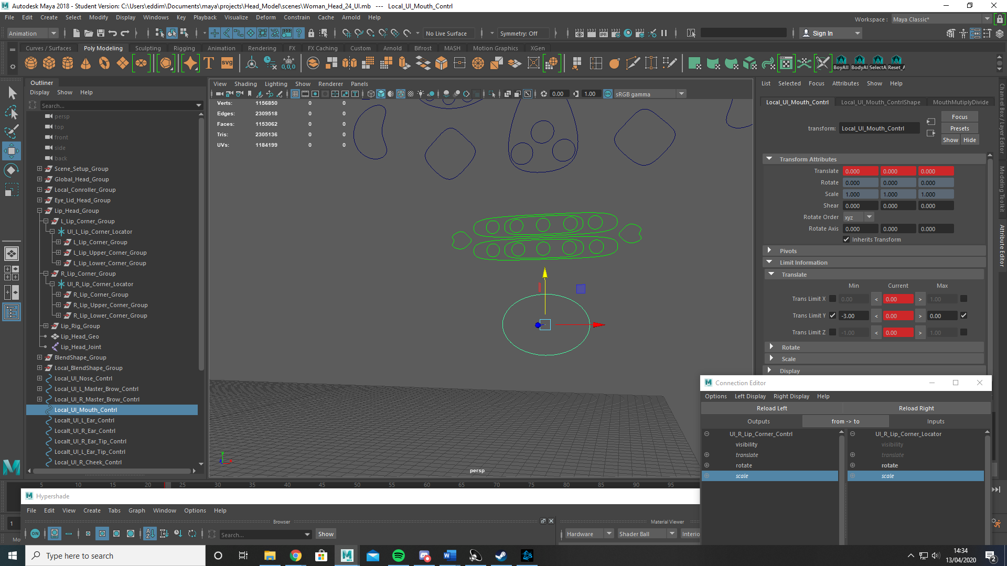

Animation

Using the old man rig provided I first used adobe premier to isolate the sound into a wave sound file before using the image sequence function to break down the video into still tiff image files of every frame.

Then in maya I created a free plane image and inserted the first frame tiff image and selected the image sequence option.

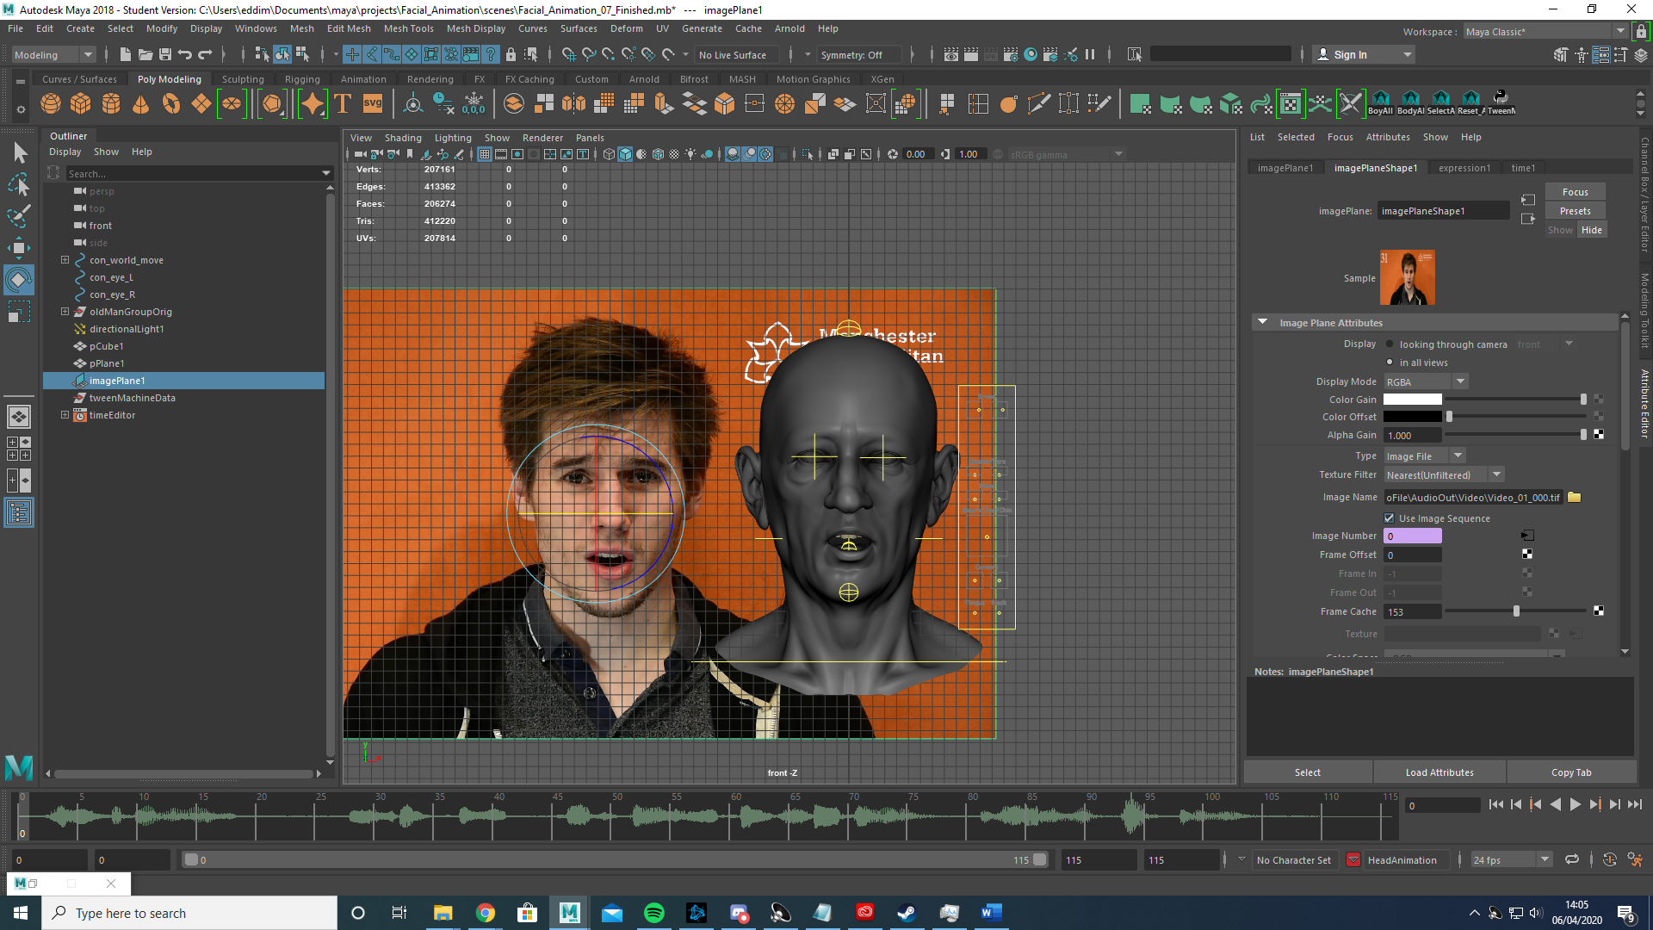

Then I simply dragged the wave sound file into the scene by dragging and dropping into the time slider.

With the set up complete I began scrubbing through the video looking for keyframes. Keyframes are frames where the face makes large easily discernible changes, for example the mouth goes from open to closed.

While some of the actor’s features had large obvious keyframes, his mouth and head in particular moved significantly, I had much more trouble identifying eyebrow and nose movement. Often the actors eyebrow movement was incredibly subtle or non-existent.

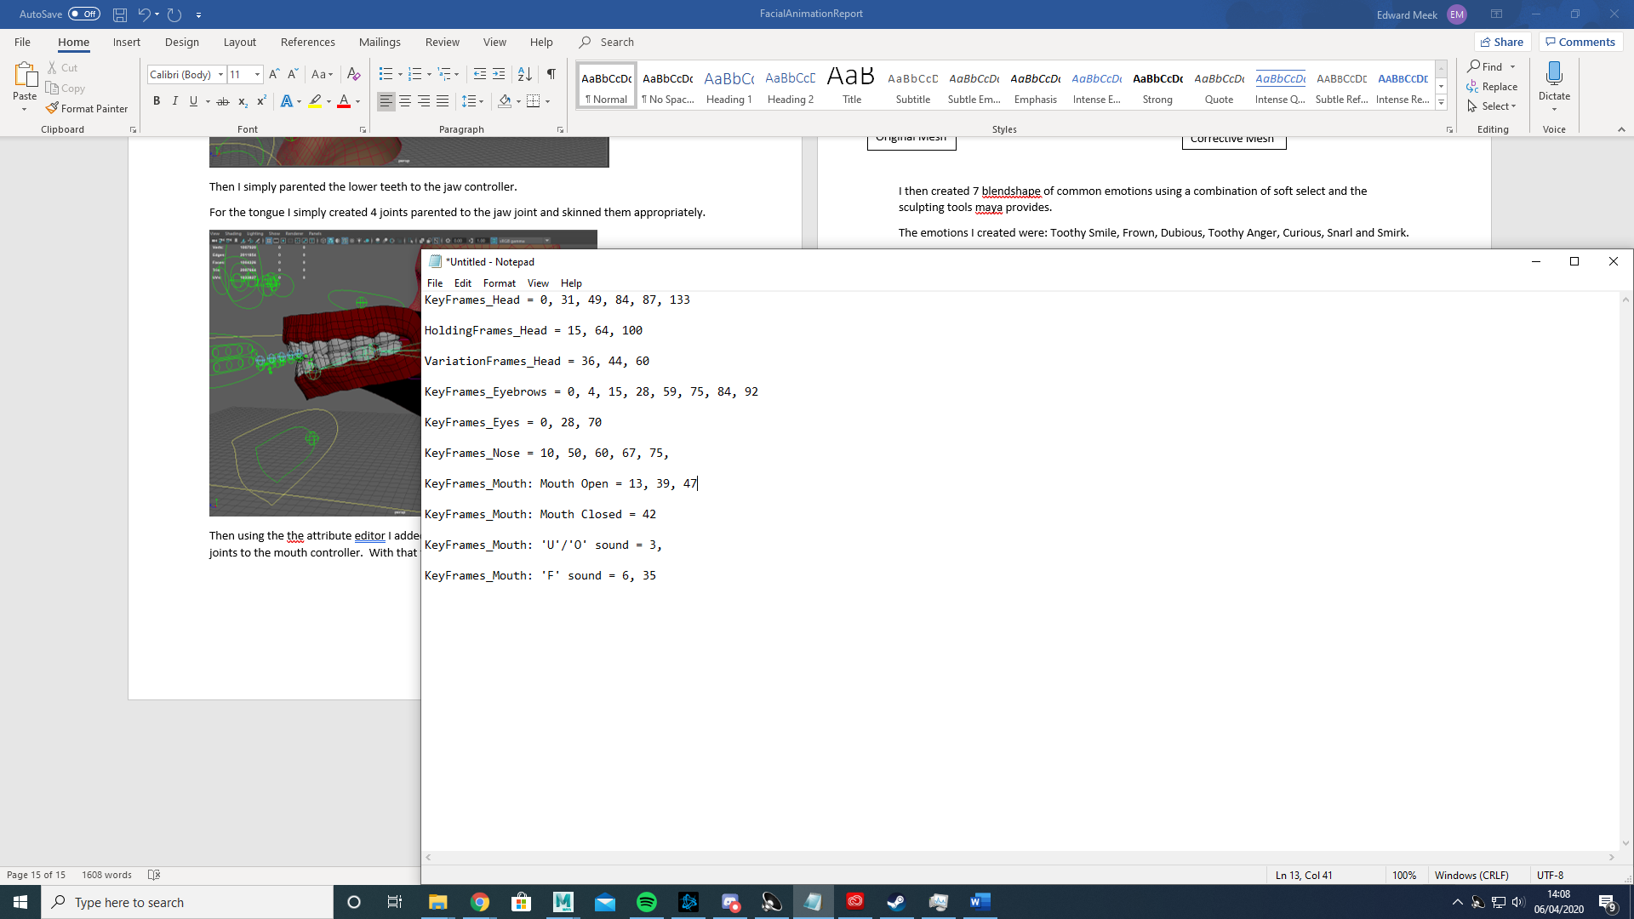

With this done I switched maya to its animation workspace, selected all of the available controllers and created a new animation layer

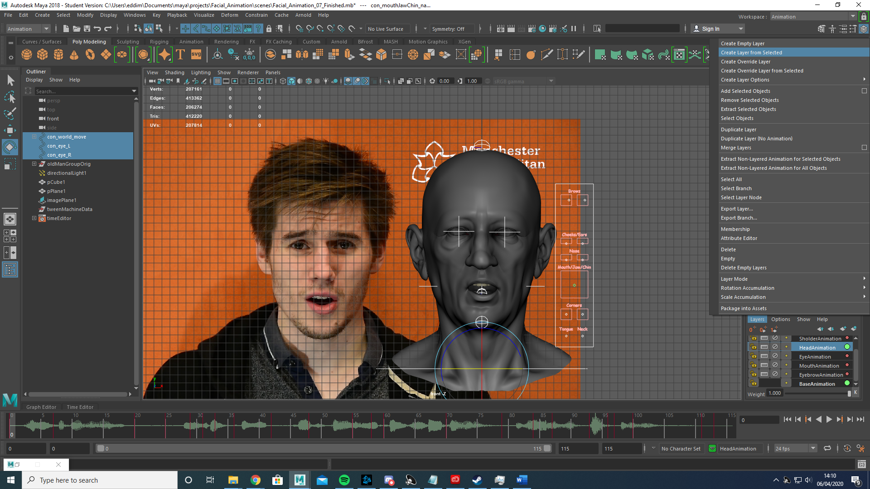

With that done I once again selected all the controllers and made another animation layer naming it eyebrow animation.

Scrubbing through the timeslider to the keyframes I used the translate manipulators on the UI as well as the custom attributes to position the eyebrows to resemble the positions of the actors eyebrows. Then selecting all of the controllers I hit the s key to set a key frame.

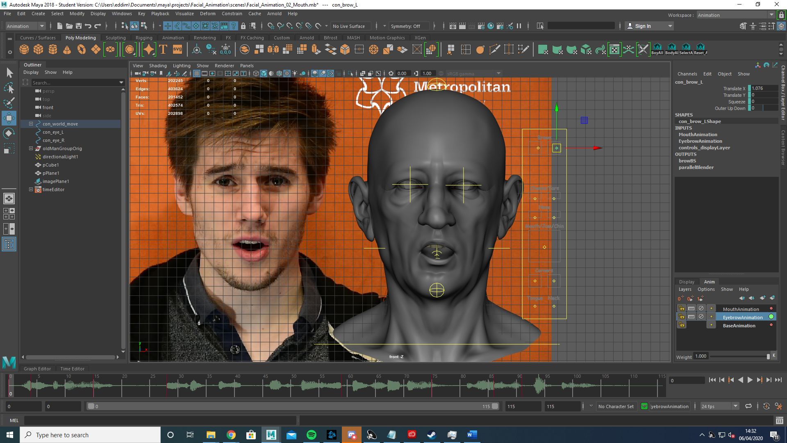

With the eyebrow keyframes done I moved to doing the same with the mouth on a separate animation layer. Unlike the eyebrows the mouth has a lot more obvious movements however a few similar shapes appear thorough the video so instead of redoing previous work I copied a frame that looked similar before using the attributes to better match the actors movements.

I repeated this workflow until I had animated the keyframes and holding frames (holding frames are frames where very little or no change occurs) of the eyebrow, mouth, eyes, head, shoulder and tongue. With this done I set about animating the more subtle movements using the same techniques I used to animate the keyframes. I also began editing the changes between the frames using the tween machine to either speed up or slow down how quickly the face chanced shape. I did this for all layers.

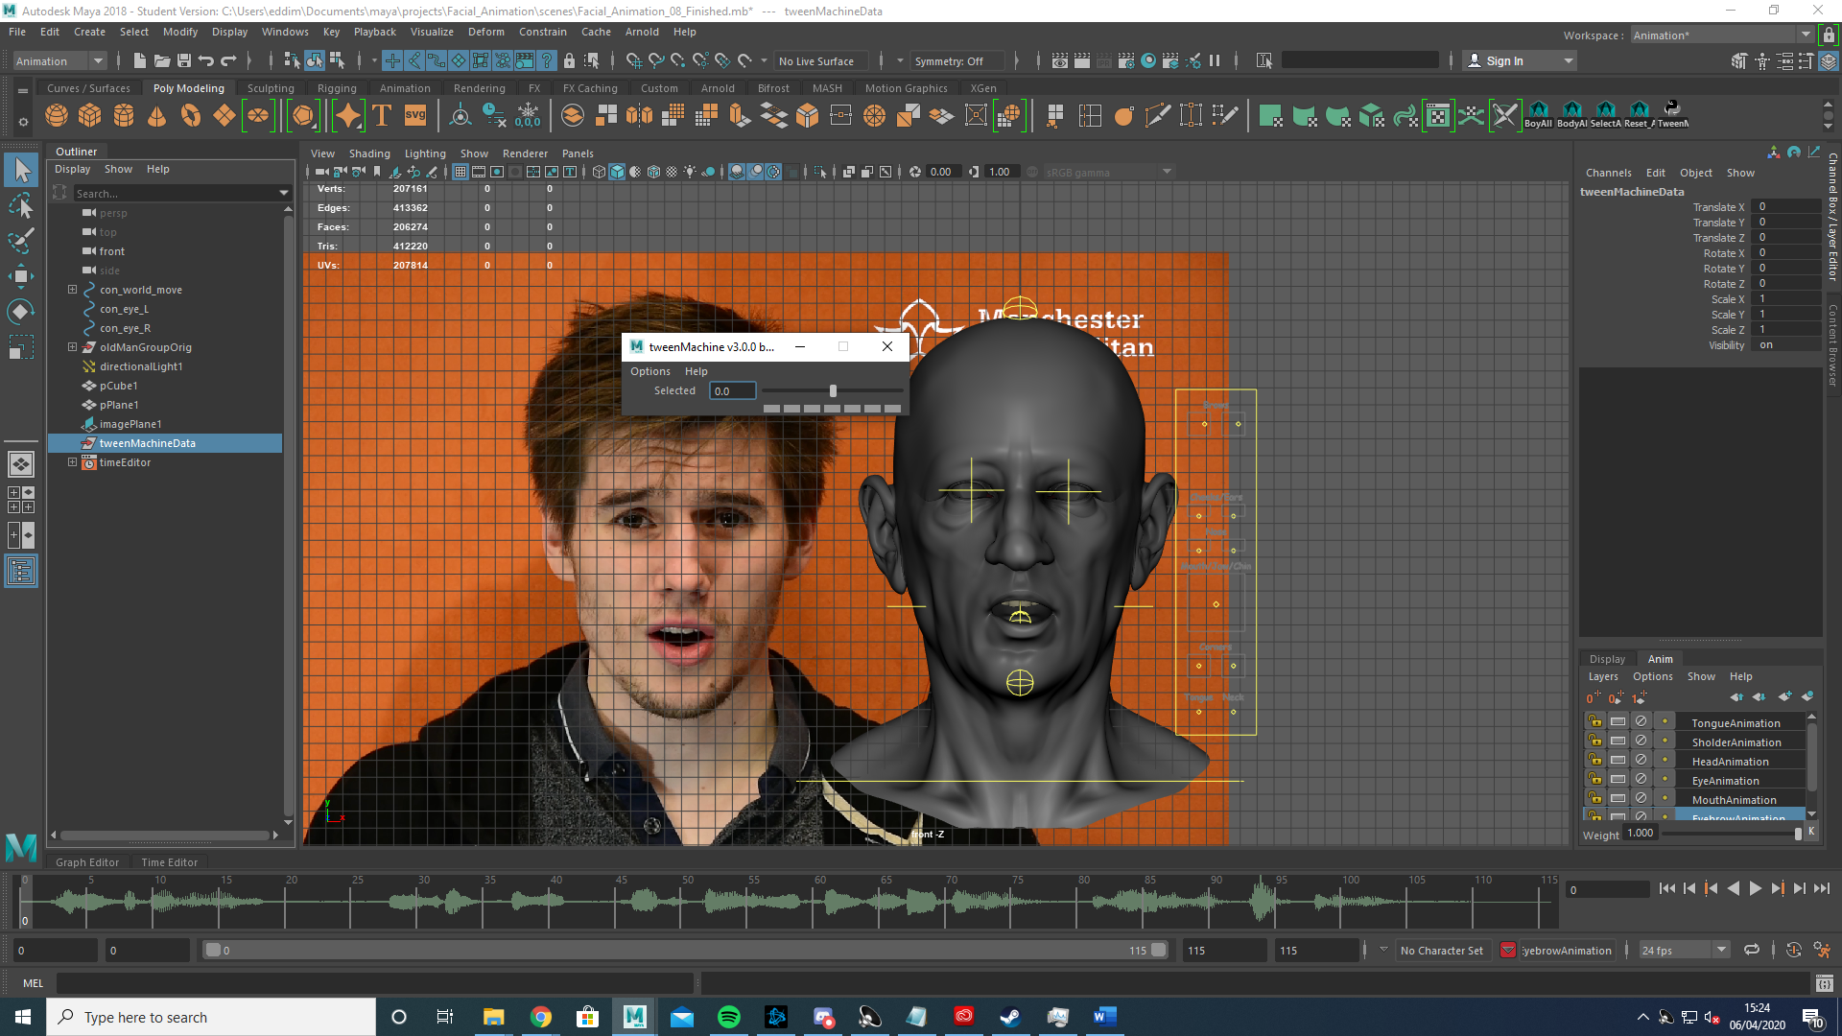

The tween machine essentially creates a keyframe between two previously made keyframes and can be weighted to happen closer to either frame.

After using the tween machine I opened the graph editor and manually smoothed out any animation changes I thought were required as well as deleted any unwanted keyframes.

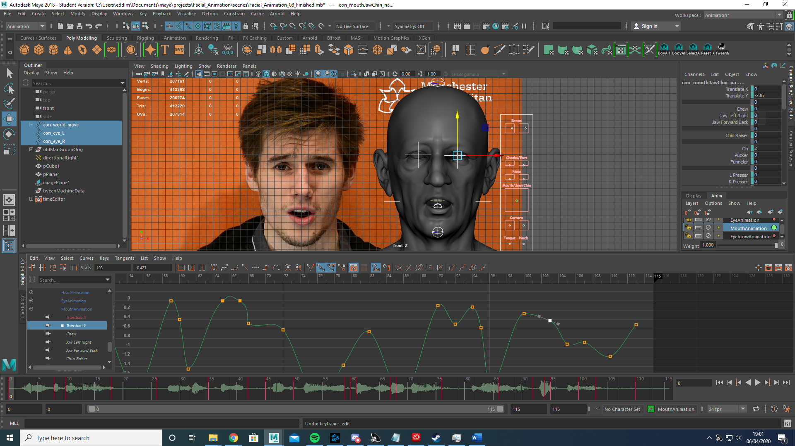

With that all done I shift selected the animation layers, merged them and then created a playblast of the animation.